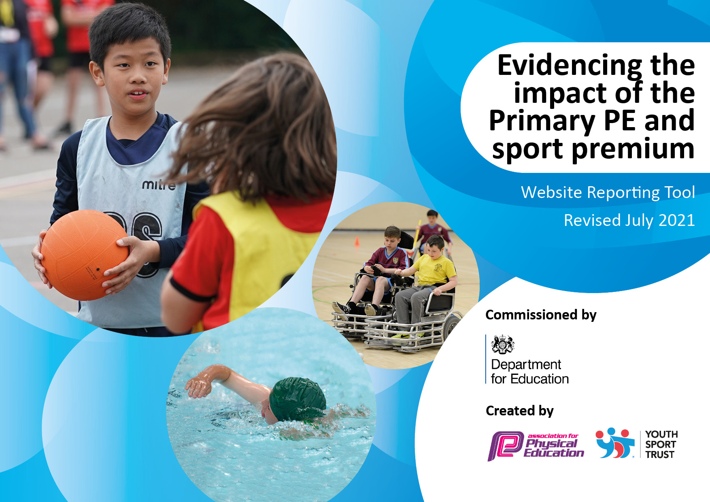
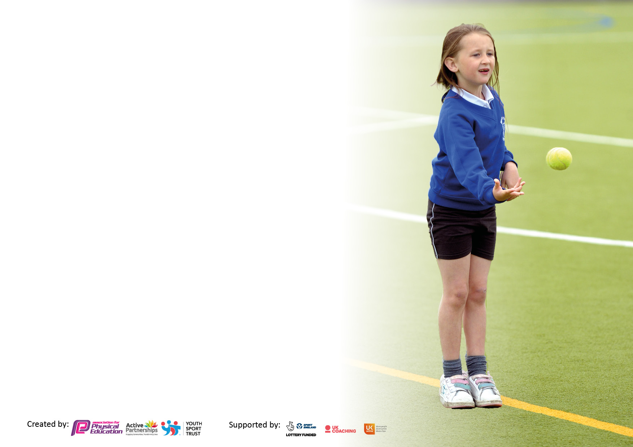

It is important that your grant is used effectively and based on school need. The Education Inspection Framework makes clear there will be a focus on ‘whether leaders and those responsible for governors all understand their respective roles and perform these in a way that enhances the effectiveness of the school’.

Under the Quality of Education Ofsted inspectors consider:
Intent - Curriculum design, coverage and appropriateness
Implementation - Curriculum delivery, Teaching (pedagogy) and Assessment
Impact - Attainment and progress

To assist schools with common transferable language this template has been developed to utilise the same three headings which should make your plans easily transferable between working documents.

Schools must use the funding to make additional and sustainable improvements to the quality of Physical Education, School Sport and Physical Activity (PESSPA) they offer. This means that you should use the Primary PE and sport premium to:

- Develop or add to the PESSPA activities that your school already offer
- Build capacity and capability within the school to ensure that improvements made now will benefit pupils joining the school in future years
- The Primary PE and sport premium should not be used to fund capital spend projects; the school’s budget should fund these.

Pleasevisitgov.ukfortherevisedDfEguidanceincludingthe5keyindicatorsacrosswhichschoolsshoulddemonstrate animprovement.Thisdocumentwillhelpyoutoreviewyourprovisionandtoreportyourspend.DfEencouragesschools to use this template as an effective way of meeting the reporting requirements of the Primary PE and sport premium.

We recommend you start by reflecting on the impact of current provision and reviewing the previous spend.

Schools are required to publish details of how they spend this funding, including any under-spend from 2019/2020, as well as on the impact it has on pupils’ PE and sport participation and attainment. All funding must be spent by 31st July 2022.

We recommend regularly updating the table and publishing it on your website throughout the year. This evidences your ongoing self-evaluation of how you are using the funding to secure maximum, sustainable impact. Final copy must be posted on your website by the end of the academic year and no later than the 31st July 2021. To see an example of how to complete the table please click HERE.

Details with regard to funding
Please complete the table below.

Total amount carried over from 2019/20 | £
Total amount allocated for 2020/21 | £
How much (if any) do you intend to carry over from this total fund into 2021/22? | £0
Total amount allocated for 2021/22 | £16,880
Total amount of funding for 2021/22. To be spent and reported on by 31st July 2022. | £16, 880
Swimming Data
Please report on your Swimming Data below.

Meeting national curriculum requirements for swimming and water safety.

N.B. Complete this section to your best ability. For example you might have practised safe self-rescue techniques on dry land which you can then transfer to the pool when school swimming restarts.
Due to exceptional circumstances priority should be given to ensuring that pupils can perform safe self rescue even if they do not fully meet the first two requirements of the NC programme of study
What percentage of your current Year 6 cohort swim competently, confidently and proficiently over a distance of at least 25 metres?  N.B. Even though your pupils may swim in another year please report on their attainment on leaving primary school at the end of the summer term 2020.  Please see note above | 100%
What percentage of your current Year 6 cohort use a range of strokes effectively [for example, front crawl, backstroke and breaststroke]?  Please see note above | 100%
What percentage of your current Year 6 cohort perform safe self-rescue in different water-based situations? | 100%
Schools can choose to use the Primary PE and sport premium to provide additional provision for swimming but this must be for activity over and above the national curriculum requirements. Have you used it in this way? | Yes/No

Action Plan and Budget Tracking
Capture your intended annual spend against the 5 key indicators. Clarify the success criteria and evidence of impact that you intend to measure to evaluate for pupils today and for the future.

Academic Year: 2021/22 | Total fund allocated: £16,900 | Date Updated: July 2022
Key indicator 1: The engagement of all pupils in regular physical activity – Chief Medical Officers guidelines recommend that primary school pupils undertake at least 30 minutes of physical activity a day in school |  |  |  | Percentage of total allocation:
 |  |  |  | 56 %
Intent | Implementation |  | Impact
Your school focus should be clear what you want the pupils to know and be able to do and about  what they need to learn and to  consolidate through practice: | Make sure your actions to achieve are linked to your intentions: | Funding allocated: | Evidence of impact: what do pupils now know and what can they now do? What has changed?: | Sustainability and suggested next steps:
To further engage all pupils in  physical activity during break and  lunchtime (Staff at break and lunchtime to engage pupils in active play) | - Invest in some high-quality playground games and storage that can easily be accessed by the children.  - Use the Sports and Wellbeing Committee members as playground leaders  - Additional MSA employed to promote and lead play  - Train MSAs to lead positive playtimes (WC join MSA meeting 11.1.22 to train on use of new equipment).  - French Skipping training to be led by HWSSP during Feeling Good Week. Including teaching Staff, Pupils and MSAs | £543.00 Playground activities-Bishops Sport and Leisure  £170.00 Additional Equipment Davies Sports  £12.00 Skipping Ropes  £5.60 Whistles for MSAs  £540.00 New small PE mats to be used for a range of activitie.  £115.00 New Storage Shed for activities  £2663.00 MSA Play leader  Part of HWSSP membership- (£1600.00 per year-logged under K1 3)  £130.00 PE equipment inspection-John Harrison | - Playtimes and lunchtimes to be observed to ensure children are active and encouraged to take part. Impact- Children are enthusiastic about sport during playtime. Improved fitness for all. Evidence: Learning walk by SLT, Pupil Voice  - New equipment in use-very popular with pupils. MSAs more engaged in play.  - French skipping workshop engaged many pupils in activity and is now a popular playtime game. Evidence: Pupil Voice, Learning Walks, photos, Feeling Good Week Survey | - LF (Fridays) and Sports Committee to work alongside MSAs in order to up skill them.  - WC to train new MSAs as part of Induction process.
To provide a Level 3 Forest School Teacher to enable high quality, active outdoor learning sessions across the school. | - Dedicated time for EO and LH to run forest school sessions with all classes.  - Forest School Extra Curricular Club | £3000.00 dedicated Forest School Salary for EO  £2,376.00 Level 2/3 Forest School training for VK/HN | - All pupils have had regular forest school provision, increasing outdoor active learning. Contributing to 100% of pupils in Reception to Year 6 accessing a minimum of 30 active minutes per day. Evidence: Forest School Planning, Photos, Pupil Voice (governor visit July 2022), Parent Voice (Parent Questionnaire-July 2022), Forest School Club register | - Funds from Forest School Club and CPD to go back into sustaining and developing the Forest further and maintaining provision for all pupils.  - New Level 2/3 leads trained-succession plan to allow for staff movement, maternity leave etc
To ensure all pupils across the school are accessing PE and Sport provision despite any barriers they may have (e.g. vulnerable groups) | - Additional PE kits available for each class to avoid any children not participating.  - Use Pupil Premium Funds to pay for pupils to participate in after school clubs, for transport to competition, sports kits etc. |  | - Pupils all able to participate in lessons, regardless of kit sent in from home.  - 100% of Pupil Premium Pupils were given the opportunity to participate in Sport/Forest School club. Evidence: Pupil Premium Records, club registers, Pupil Premium flyer sent out to parents | - Purchase some new kits in September 2022
Key indicator 2: The profile of PESSPA being raised across the school as a tool for whole school improvement |  |  |  | Percentage of total allocation:
 |  |  |  | 0.04 %
Intent | Implementation |  | Impact
Your school focus should be clear what you want the pupils to know and be able to do and about  what they need to learn and to  consolidate through practice: | Make sure your actions to achieve are linked to your intentions: | Funding allocated: | Evidence of impact: what do pupils now know and what can they now do? What has changed?: | Sustainability and suggested next steps:
To develop more structured, active playtimes to increase activity levels and help reduce playground injuries and behaviour incidents. | - Invest in some high-quality playground games and storage that can easily be accessed by the children.  - Use the Sports and Wellbeing Committee members as playground leaders  - Additional MSA employed to promote and lead play  - Train MSAs to lead positive playtimes (WC join MSA meeting 11.1.22 to train on use of new equipment).  - French Skipping training to be led by HWSSP during Feeling Good Week. Including teaching Staff, Pupils and MSAs | See Key Indicator 1 | - Children are enthusiastic about sport during playtime. Reduction in incidents and accidents Evidence: Learning walk by SLT, Pupil Voice, CPOMS records analysis, Headteacher’s Report  - New equipment in use-very popular with pupils. MSAs more engaged in play.  - French skipping workshop engaged many pupils in activity and is now a popular playtime game. Evidence: Pupil Voice, Learning Walks, photos, Feeling Good Week Survey | - Continue to develop next year-plans for fixed netball posts on the playground and basketball hoops on the MUGA
To use the Commonwealth Games to inspire and engage pupils in Sport. | - Commonwealth Games Assembly  - Research and work on allocated Commonwealth Country-Samoa  - Represent Samoa in World Wide Wodson Games  - Engage Pupils in Perry’s Personal Challenges  - Baton Relay Activity  - Commonwealth inspired Sports Day | Resources either free or funded through HWSSP  £8.00 Stickers for Sports Day | - Increased uptake in sports from all pupils (  - Pupils have a better understanding of the Commonwealth sports and the countries involved.  - Pupils tried new skills and activities through the Perry’s Challenges.  Evidence; Perry’s Personal Challenge Records, sports day photos, Commonwealth country research sheets, School Games Noticeboard, | - Use the Perry’s Personal Challenges weekly from September 2022

Key indicator 3: Increased confidence, knowledge and skills of all staff in teaching PE and sport |  |  |  | Percentage of total allocation:
 |  |  |  | 9.48 %
Intent | Implementation |  | Impact
Your school focus should be clear | Make sure your actions to | Funding | Evidence of impact: what do | Sustainability and suggested
what you want the pupils to know | achieve are linked to your | allocated: | pupils now know and what | next steps:
and be able to do and about | intentions: |  | can they now do? What has
what they need to learn and to |  |  | changed?:
consolidate through practice:
To ensure the PE subject lead keeps up to date. | - CPD opportunities through membership of HWSSP  - Tennis Teacher Training for WC from LTA (offered through HWSSP) | HWSSP membership- £1600.00 per year | - WC attended CPD events in the Autumn and Spring Term-keeping up to date with guidance, engaging in discussion with colleagues and benefitting from support. Information disseminated to school staff.  - WC confident in the delivery of Tennis. Resources provided from the LTA as a result of training. This is to be shared with other staff in school.  - Weekly updates from HWSSP SGO allowed us to keep abreast of updates, competitions and useful resources and in turn helped provide many excellent sporting opportunities for pupils.  Evidence: HWSSP communications, LTA training certificate, notes from CPD opportunities, participation in events promoted at CPD sessions.
Key indicator 4: Broader experience of a range of sports and activities offered to all pupils |  |  |  | Percentage of total allocation:
 |  |  |  | 0.3%
Intent | Implementation |  | Impact
Your school focus should be clear | Make sure your actions to | Funding | Evidence of impact: what do | Sustainability and suggested
what you want the pupils to know | achieve are linked to your | allocated: | pupils now know and what | next steps:
and be able to do and about | intentions: |  | can they now do? What has
what they need to learn and to |  |  | changed?:
consolidate through practice:
To broaden range of extra-curricular clubs and increase uptake. | - R-KS1 multisport club to be offered by LF Friday lunchtimes (Autumn and Spring)  - Year 2-6 after school Multi Sport Club offered by SC (Autumn and Spring). Changed to Reception to Year 2 in Summer Term.  - Thomas Tigers Training lead by LF-after school in Autumn and Spring Term, at lunchtime in Summer Term.  - Cricket Club to be offered by LF afterschool in the Summer Term.  - Cheerleading club to be offered after school Reception to Year 6  - After school Netball Club offered for KS2.  - Forest School club after school-Reception to Year 6 | See Sports Coach Salary under other indicators.  Pupil Premium used to fund club attendance to those in receipt of FSM  £30.00 Footballs | - High uptake of clubs-in the Autumn Term this was 63% whole school engagement, 82% of KS2 accessing extra-curricular provision. By the Summer Term 2022 98% of KS2 has attended one of our sports and activity clubs. Evidence: Clubs registers, pupil voice, parent voice | - Use pupil voice to find out what other sorts of sports and activity clubs children would like-focus on Younger Pupils.  - Look into before school clubs and provision based on successful model of other local school
To introduce a cricket club for KS2 in the Summer Term of 2022. | - In Summer Term, Senior Sports Coach to move Thomas Tigers Training to lunchtime to enable him to lead Cricket Club after school on Fridays. | £ See Sports Coach Salary under Key Indictor 5  £20.00 Kwick Cricket Balls for Club | - KS2 pupils given the opportunity to join a new club and participate in a cricket tournament (June 2022). Evidence: Club register, Dynamo Tournament Results sheet. Photos, Pupil and Parent Voice | - Develop cricket club further next year. Consider introducing a KS1 and EY club.

Key indicator 5: Increased participation in competitive sport |  |  |  | Percentage of total allocation:
 |  |  |  | 34%
Intent | Implementation |  | Impact
Your school focus should be clear | Make sure your actions to | Funding | Evidence of impact: what do | Sustainability and suggested
what you want the pupils to know | achieve are linked to your | allocated: | pupils now know and what | next steps:
and be able to do and about | intentions: |  | can they now do? What has
what they need to learn and to |  |  | changed?:
consolidate through practice:
To build upon Gold Kitemark Award and identify opportunities for  participation in competitive events. | - WC and LF work together on School Games Mark to maintain Gold.  - Participate in virtual competitions-Pudsey Skipping Challenge, Y3/4 and 5/6 Pentathlon  - Participate in face to face competitions- Football (Hope Cup and District), Cricket, Tag Rugby, Wodson Games  - Personal Challenges: Weekly record of Daily Mile results-aiming to improve, Engage in the Perry’s Personal Challenges inspired by the Commonwealth Games | £ Salary for Senior Sports Coach- See below  £65.00 transport to Year 5/6 Tag Rugby Tournament  £40.00 for bus transport to the St Mary’s Netball/Football Catholic Schools Tournament (shared with another school) | - 100% of Year 6 pupils entered at least 2 inter school competitive events this year (Football, Netball, Rugby, Cricket)  - 60% of Year 3-5 participated in inter school competitive sport this year (Football, Cricket)  - 2nd Place Achieved by Year 6 in both the Catholic Schools Netball and Football Competitions (June 2022)  - 100% of KS2 pupils participated in intra school competitions. -football, speed-stacking, Pentathlon,  - Many Younger Pupils engaged by Perry’s Personal Challenges  - Gold Kitemark Validated July 2022!  Evidence: Competition results, Records of Perry’s Personal Challenges, Pupil Voice, Photos, School Games Mark | - Look at introducing Dodgeball club and entering new league new year.  - Continue to use Perry’s Personal Challenges-set pupils a challenge of the week
To further develop the Thomas Tigers KS2 football team. | - Senior Sports Coach to lead weekly Thomas Tigers Training sessions.  - Enter ‘friendly’ Small Schools football league (HWSSP) in the Autumn Term 2021.  - Enter Hope Cup Football Tournament Spring 2022 (HWSSP)-NB due to COVID disruption the Hope Cup was unable to continue this year  - Enter the Year 5/6 District Football competition in March 2022. | £5562.17- Salary for Senior Sports Coach | - 100% of Year 6 able to participate in competitive events-Thomas Tigers was a big contributor to this. Evidence: Permission slips, team sheets, photos, Pupil and Parent Voice, club registers | - Year 3 and 4 pupils have been involved in training this year as well as their own district football tournament. This means they are well prepared as they move to more competitive opportunities in Year 5/6.

Signed off by
Head Teacher: | Michelle Keating
Date: | 22nd July 2022
Subject Leader: | Wendy Clark
Date: | 22nd July 2022
Governor: | Mary Lennon
Date: | 22nd July 2022

