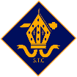
St. Thomas Catholic Primary School - Handwriting Progression Map EYFS to Year 6
This is the sequence that is followed, with explicit teaching, modelling and practising at each stage:  - Gross and fine motor skills (supporting the ‘P checks’)  - Accurate letter formation (shape, spacing, sitting on the line, letter size, string)  - Fluency and stamina (slant, speed and style)  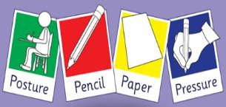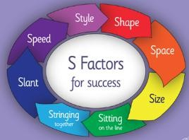 | These are the four-letter families and order that they are taught:  - Ladder Letters: l, t, I, j, u, y  - Curly Caterpillar Letters: c, o, a, d, g, q, s, f, e  - One-Armed Robot Letters: r, n, m, h, b, p  - Zigzag Monster Letters: v, w, z, x, k  Capital Letters A - Z Digits 0-9 |  | These are the four main joins and order that are taught and examples of the joins:  - Diagonal joins to letters without ascenders  (eg) ai, ar, un, am, ear, aw, ir, hu, ti, ki, du, up, ag, fe, fu.  - Diagonal joins to letters with ascenders  (eg) ab, ul, it, ib, if, ub, th, ck, ch, it, ft, fl.  - Horizontal joins to letters without ascenders  (eg) ou, vi, wi, op, ow, ov, ri, ru, ve, we, re.  - Horizontal joins to letters with ascenders  (eg) ob, ol, wh, it, of, rt, rk.  Break letters (letters that aren’t joined from): b, g, j, p, q, x, y, z, s
Links to phonic knowledge and development
As children begin learning the pure sounds in EYFS (Level 2 graphemes), reference is made to the pictures and the formation phrase from Little Wandle SSP which acts as an aid in helping the children to write the grapheme.

The development of a tripod grasp  There are developmental stages that a child may go through when learning to hold a pencil. In all year groups, we remind  children to use the appropriate grasp when writing. (If children are finding this difficult, triangular pencils or pencil grippers can be used to support this.)  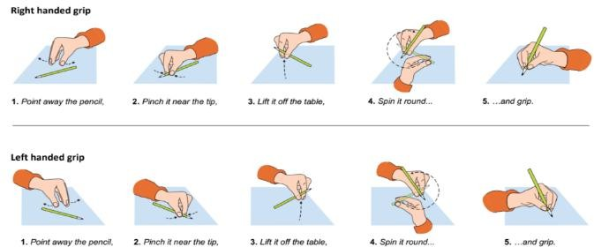 |  | Handwriting position  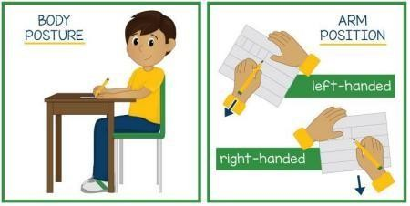  Posture:  Children are taught the importance of sitting upright and correctly on their chair, with their feet on the floor, their chair tucked in and their bottom at the back of the seat.  Position of paper:  Left-handed children are encouraged to tilt their  paper slightly to the right to improve their view of what they are writing, and to reduce smudging. Right-handed children may find it helpful to tilt paper slightly to the left. Paper is steadied with the free hand.

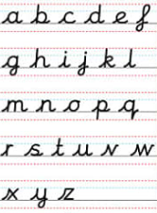
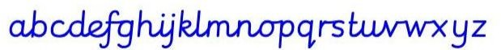
Our handwriting style

EYFS & Year 1 – Simple modern cursive – Print. (Note the curly k – this might be one of the last letters addressed – some children might not achieve this but should progress to the next level, nevertheless.)

Years 2, 3 & 4 - When letter formation and positioning are both secure, joining is taught. Some break letters are left un-joined.

Years 5 & 6 – Fully cursive. (Note the letters can now be all joined together. F now has an ascender loop, g, j and y have descender loops.)

What a handwriting lesson / sequence looks like:
- Handwriting warm-up exercises: Shoulder stability and strength; Crossing the mid-line; Wrist strength and flexibility; Thumb and finger strength and dexterity; Whole hand strength and dexterity.

- The ‘P’ checks: Posture, Pencil, Paper, Pressure.

- Teacher modelling of letter formation and joins, with reference to relevant S factors for success.

- Opportunities to practise and apply, with direct, in the moment, intervention / support / explicit feedback for individual children based on AFL.

- Assessment of skill through dictation of single words / phrases / sentences.

EYFS Handwriting
EYFS Requirements (Development Matters)
- Develop their fine motor skills so that they can use a range of tools competently, safely and confidently. Suggested tools: pencils for drawing and writing, paintbrushes, scissors, knives, forks and spoons. (PD)
- Use their core muscle strength to achieve a good posture when sitting at a table or sitting on the floor. (PD)
- Develop the foundations of a handwriting style which is fast, accurate and efficient. (PD)
- Form lower case and capital letters correctly. (LIT)
ELGs:
- Hold a pencil effectively in preparation for fluent writing – using the tripod grip in almost all cases. (PD)
- Write recognisable letters, most of which are correctly formed. (LIT)

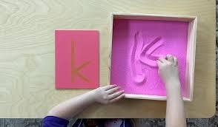
Daily mark making activities alongside direct teaching. Daily opportunities to improve fine motor skills.
Autumn | Spring | Summer
- Teach letter formation alongside Phase 2 graphemes, using Little Wandle formation phrases. Use whiteboards and pens to teach letter formation during phonics lessons but ensure the children follow clear routines for using them.  - Provide additional practice of letter formation in handwriting lessons outside of the phonics lessons. For this, children should be sitting comfortably. Use the lesson to focus on correct pencil grip, letter formation and orientation, and correct posture. Twinkl letter formation practice sheets can be used as part of a handwriting lesson and as additional guided practice of letter formation.  - Teach the formation of capital letters and corresponding lower-case letters. | - Teach letter formation alongside Phase 3  graphemes, using the Little Wandle formation phrases. Use whiteboards and pens to teach letter formation during phonics lessons but ensure the  children follow clear routines for using them.  - Provide additional practice of letter formation in handwriting lessons outside of the phonics lessons. For this, children should be sitting comfortably. Use the lesson to focus on correct pencil grip, letter formation and orientation, and correct posture. Twinkl letter formation practice sheets can be used as part of a handwriting lesson and as additional guided practice of letter formation.  - Teach the formation of capital letters and corresponding lower-case letters. | - Consolidate letter formation of lower-case letters, in line with Phase 4 graphemes.  - Teach the formation of capital letters and corresponding lower-case letters.  - Teach the formation of digits 0 – 9.

Year 1 Handwriting
National Curriculum Statutory Requirements
- Sit correctly at a table, holding a pencil comfortably and correctly.
- Begin to form lower-case letters in the correct direction, starting and finishing in the right place.
- Form capital letters.
- Form digits 0 to 9.
- Understand which letters belong to which handwriting 'families' (letters that are formed in similar ways) and to practice these.

Daily practice of letter formation, helping children to progress from accuracy to fluency – outside of phonics lesson (10 minutes).
Direct, in the moment intervention / support / explicit feedback for individual children based on AFL (linked to sitting position, grip, letter formation).
Autumn | Spring | Summer
- Opportunities and activities for children to  improve their fine motor skills and master pencil grip.  - Consolidation of letter formation of lower-case letters:  - Ladder Letters: l, t, i, j, u, y  - Curly Caterpillar Letters: c, o, a, d, g, q, s, f, e  - One-Armed Robot Letters: r, n, m, h, b, p  - Zigzag Monster Letters: v, w, z, x, k  - Integrate the teaching of capital letters (A-Z) alongside the lower-case letters:  - Ladder Letters: l, t, i, j, u, y  - Teach the formation of digits 0 – 9. | - Opportunities and activities for children to  improve their fine motor skills and master pencil grip  - Integrate the teaching of capital letters (A-Z) alongside the lower-case letters:  - Curly Caterpillar Letters: c, o, a, d, g, q, s, f, e  - One-Armed Robot Letters: r, n, m, h, b, p  - Zigzag Monster Letters: v, w, z, x, k  - Re-cap the formation of digits 0 – 9 | - Opportunities and activities for children to  improve their fine motor skills and master pencil grip  - Show more control and accuracy when writing correctly formed lower-case letters and capital letters:  - Ladder Letters: l, t, i, j, u, y  - Curly Caterpillar Letters: c, o, a, d, g, q, s, f, e  - One-Armed Robot Letters: r, n, m, h, b, p  - Zigzag Monster Letters: v, w, z, x, k  - Re-cap the formation of digits 0 – 9.  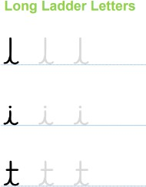

Year 2 Handwriting
National Curriculum Statutory Requirements
- Form lower-case letters of the correct size relative to one another
- Start using some of the diagonal and horizontal strokes needed to join letters and understand which letters, when adjacent to one another, are best left unjoined.
- Write capital letters and digits of the correct size, orientation and relationship to one another and to lower case letters.
- Use spacing between words that reflects the size of the letters.

Teach and practice correct cursive letter formation 3 times a week (15 minutes).
Write with a joined style as soon as they can form letters with horizontal/diagonal joins correctly.
Direct, in the moment, intervention / support / explicit feedback for individual children based on AFL.
Autumn | Spring | Summer
- Recap letter groups (lower case and capital letters), ensuring correct letter formation and orientation:  - Ladder Letters: l, t, i, j, u, y  - Curly Caterpillar Letters: c, o, a, d, g, q, s, f, e  - One-Armed Robot Letters: r, n, m, h, b, p  - Zigzag Monster Letters: v, w, z, x, k  - Diagonal joins to letters without ascenders (eg) ai, ar, un, am, ear, aw, ir, hu, ti, ki, du, up, ag, fe, fu. | - Diagonal joins to letters with ascenders (eg) ab, ul, it, ib, if, ub, th, ck, ch, it, ft, fl.  - Horizontal joins to letters without ascenders (eg) ou, vi, wi, op, ow, ov, ri, ru, ve, we, re. | - Horizontal joins to letters with ascenders (eg) ob, ol, wh, it, of, rt, rk.  - Consolidation of the four main joins.  - Recap on specific letter joins to ensure children are writing in a fluent style.

Lower Key Stage 2 Handwriting 3/4
National Curriculum Statutory Requirements
- Use the diagonal and horizontal strokes that are needed to join letters and understand which letters, when adjacent to one another, are best left unjoined.
- Increase the legibility, consistency and quality of their handwriting (for example, by ensuring that the downstrokes of letters are parallel and equidistant; that lines of writing are spaced sufficiently so that the ascenders and descenders of letters do not touch).

Weekly discrete handwriting lesson and twice weekly handwriting practise using spellings. (10 minutes) Direct, in the moment, intervention / support / explicit feedback for individual children based on AFL.
- Recap the four main joins, with daily application of one join before focusing on developing a fluid style:
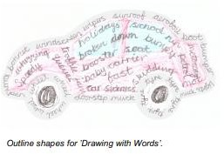
  - Diagonal joins to letters without ascenders
  - Diagonal joins to letters with ascenders
  - Horizontal joins to letters without ascenders
  - Horizontal joins to letters with ascenders
- Apply to spellings and dictated sentences.
- Practise combining all 4 joins when writing sentences.
Upper Key Stage 2 Handwriting 5/6
National Curriculum Statutory Requirements
- Write legibly, fluently and with increasing speed by: choosing which shape of a letter to use when given choices and deciding whether or not to join specific letters; choosing the writing implement that is best suited for a task.

Practise once or twice weekly using weekly spellings. (10 minutes)
Direct, in the moment, intervention / support / explicit feedback for individual children based on AFL
- Recap the letter families and all the joins, introducing a fully cursive style, with daily application of one join before focusing on developing a fluid style.
- Rehearsal through spelling, dictated sentences and copying short passages.

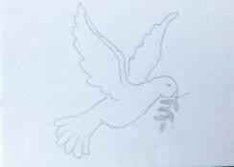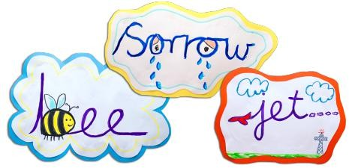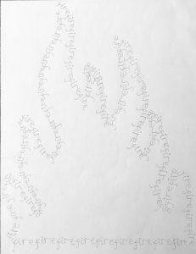


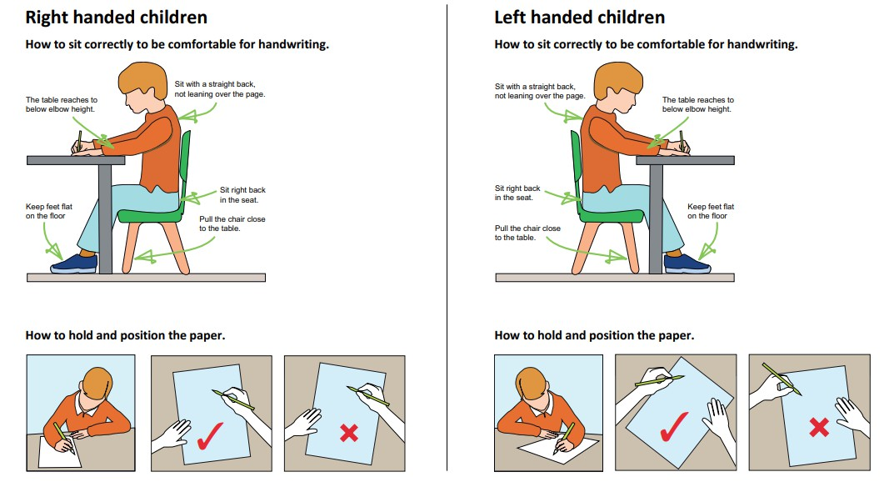


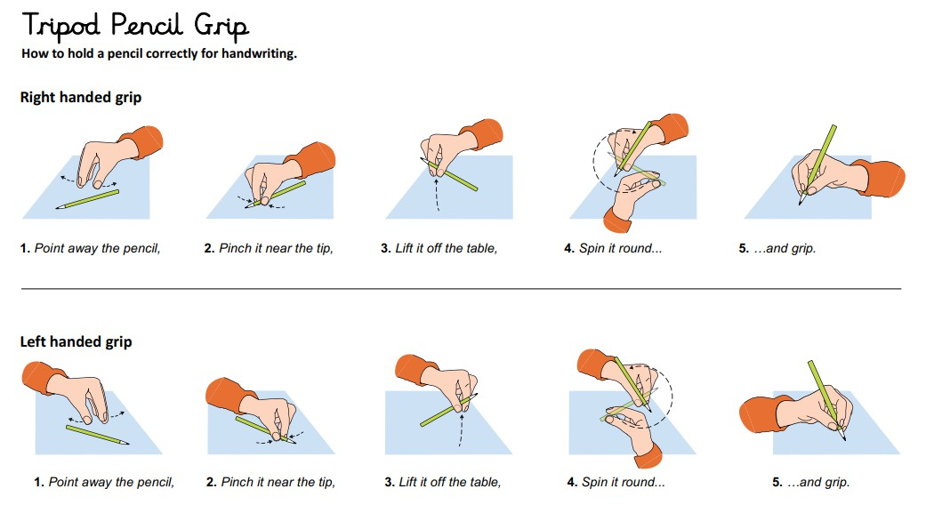

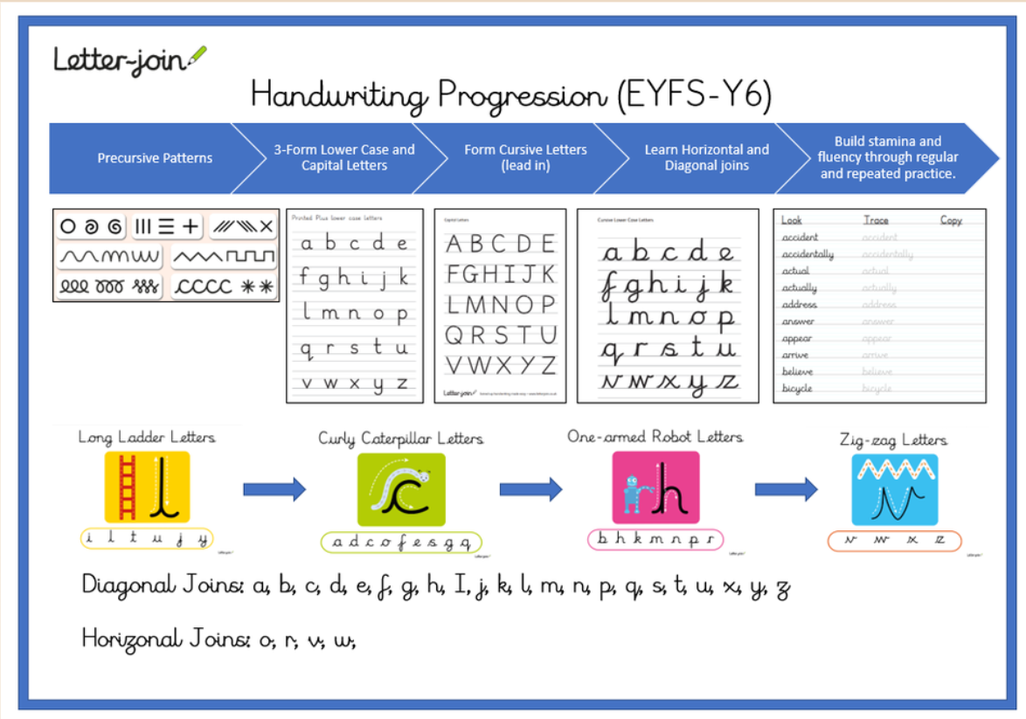

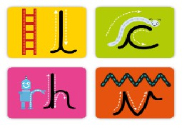

Posture Rhyme


