
Prayer in the Catholic tradition is rich and varied and can take numerous forms for example:
St Thomas of Canterbury Catholic Primary School
Creative Ways to Pray with Children
- Using a formula (eg Sign of the Cross)
- Traditional prayer (eg The Lord’s Prayer, Hail Mary, Glory Be)
- Spontaneous prayers (Expressing thoughts and needs)
- Petition, thanksgiving, praise, intercession, penance
- Meditation, contemplation (eg Lectio Divina, Examen, Rosary)
- Liturgical celebrations (eg Mass, Adoration/Benediction)
Praying can also be done in a number of creative ways, here are just a few ideas…
Bubble Prayers
You will need bubble blowing kits and a dry, not too windy, day. Get your child to focus upon someone they wish to pray for. As they blow a bubble they can pray for that person ‘Jesus be with…’, ‘God our Father help…’, Holy Spirit protect….’. The bubble rising into the air is a visual reminder that we offer our prayers up to God.
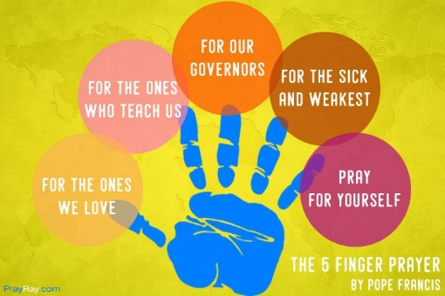
5 Finger Prayer
Developed by Pope Francis, this prayer practice assigns each finger something to pray for. The thumb is for those closest to us. The index finger for those who teach, instruct and heal us. The middle finger, our tallest, is for our leaders. The ring finger, our weakest, for those who are weak. The pinky is for ourselves.

Prayer Balls
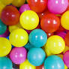
You will need some cheap balls (e.g. ball pool balls or table tennis balls). Explain to your child that each ball represents a different type of prayer. Pull a ball out of a bag and pray the prayer that the colour indicates. There are some ideas below, depending on what colour balls you have!
Red: Pray a sorry prayer
Blue: Pray for the environment/animals
Green: Pray for your family
Yellow: Pray for people who are poorly
Pink: Pray for your friends
Orange: Pray for other countries
Teaspoon Prayers
Using the acronym for teaspoon, TSP, help your child to pray as follows: T = Thank you S = Sorry P = Please You may like to give the children a teaspoon to help remember the pattern. You can either pray all three of these things or you may like to do just one, but this is a simple and easy way to help children build a relationship with God.
Reflection Bottles
This idea works well with children who are visual, giving them something to focus on while they are reflecting or listening to God. Pour some glitter or glitter glue (either will work) into a plastic bottle and fill the bottle with water. It doesn’t matter where the glitter congregates in the bottle! You may like to use one colour of glitter or a mixture. Shake the bottle and watch! It's actually quite fascinating and peaceful. Allow the children to tell you how it feels and what they think God is revealing to them.
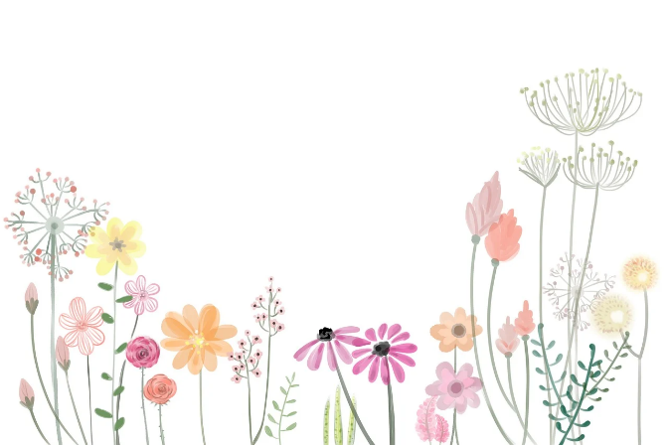
Prayer Walk
Go for a walk together in search of things in creation that the children can thank God for. Pathways, trees, the sky, nature, bird songs, animals, flowers, plants, bees and fresh air. There is SO much to appreciate! This is an excellent way to get outside, slow down the mind and get active together. You could photograph the things you say thanks for and add to the prayer book/journal.

Pebble Drop Prayers
Provide a large bowl of water and a variety of pebbles. Allow your child a few moments to think what they would like to pray for. Invite them to approach the bowl and drop their pebble into the bowl, quietly praying as they watch it sink to the bottom. It may be that there’s a sense of leaving this prayer in God’s hands. God promises to hear and answer our prayers.
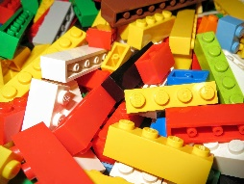
Building the Kingdom
This prayer uses building blocks such as Lego® or an equivalent. Each family member takes one brick. What can you make with your piece? It has the potential to be a house, a car, or a rocket, but to fulfil that potential it needs other pieces. In the same way, each of us has unique gifts and if we bring them together, we can build something amazing. Say which gifts you recognise in each other.
“For the Kingdom of God is... living a life of goodness and peace and joy in the Holy Spirit.” Romans 14:17
Spend some time as a family discussing Saint Paul's words to the Romans. How can we live a life of goodness, peace and joy and so build up God's kingdom? How can we reach out to our brothers and sisters throughout the world in love?
Use some building blocks to build something inspired by this, and as you do, pray God will help you to build his kingdom. You might like to display your creation for some time as a reminder of the prayer.
Playdough Prayers
Each family member needs a piece of play dough, the invitation is to shape it in different ways in response to the following prayer prompts:
A ball - Thank God for the gift of creation and ask him to help your family and all people to care for the earth.
Divided into two or more pieces - Think of all the places where people are divided by war or disagreement. As you bring the pieces back together pray that God will bring peace and healing. You may wish to reshape the pieces into a dove or another symbol of peace.
A rainbow - Many people put rainbows in their windows as a sign of hope during the pandemic. Offer your hopes to God and pray for a fairer world for all people.
Stretched out as far as it can go - Pray God will help you to reach out to those in need.
A heart - Pray for the people you love and the people who love you.
Your own shape - Finish by shaping the dough into something to express your own prayer.
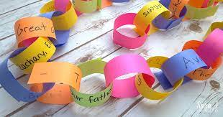
Paper Chain Prayer
You will need strips of coloured paper and glue or a stapler (you can buy pregummed paper strips). Get your child to write their prayers on a strip of paper. Try to focus on a specific type of prayer (thanks, praise etc.) or give them something specific to pray for. Join the prayers together to make a chain and place them somewhere at home. You could build up a chain over a period of time by adding to it gradually. You could have different coloured strips to symbolise different types of prayer. This idea gives children a tangible way to help them understand how our prayers can be joined together as an offering to God. With older children you can talk about the work of Blessed John Henry Newman who spoke about us all being links in a chain.

Jellybean Prayers
This colour of each jellybean reminds children of part of the story of Jesus’ life, death and resurrection. You will need some jellybeans (or other coloured sweets) and a copy of the prayer below. Take it in turns to choose a sweet. As it is eaten, focus upon the significance of the colour that has been chosen. There are a few different versions of this prayer about. You might get the children to make up their own. The colours can also be used to associate with particular types of prayer such as purple for penance, green for creation etc.
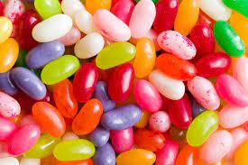
Red is for the blood Jesus shed
Green is for new life ahead
Black is for the sins we’ve made
White is for the forgiveness he gave
Yellow is for the beautiful sunlight
Orange is for the edge of night
Purple is for his hour of sorrow
Pink is for our new tomorrow.
Lolly Stick Prayers
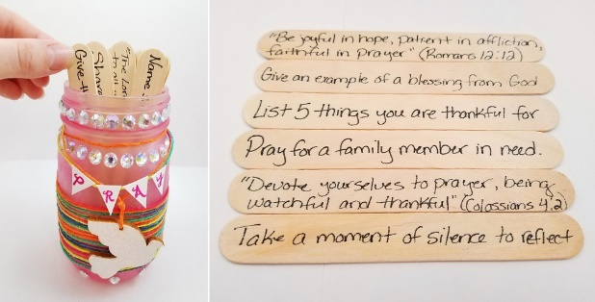
Works best with wide lolly sticks. Get your child to write things/people they wish to pray for on lolly sticks and place in a pot or jar. Each day they can choose a prayer to say.

Prayer Aeroplanes
Give your child an A4 sheet of paper and ask them to write or draw a prayer. Explain that when we pray, our prayers go straight to God’s ears, and he hears each one of them. Show this visually by writing the word GOD on a large sheet of card or paper and placing it on the floor. Ask the child to throw their paper aeroplane to land on the card. Let them have a few goes. Emphasize that our planes might miss the mark but our prayers won’t – they always reach God.

Please feel free to share any of your own creative ideas for prayer!

