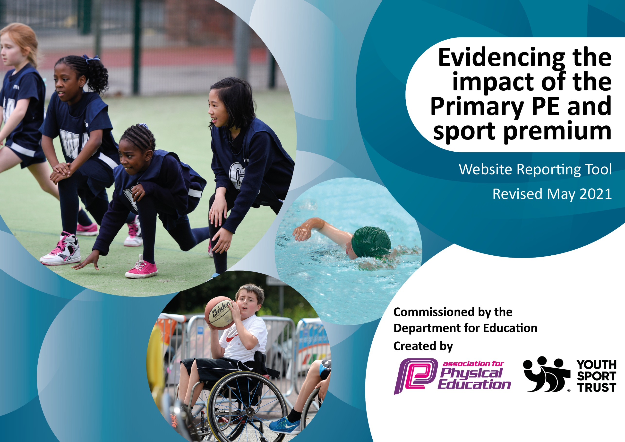

It is important that your grant is used effectively and based on school need. The Education Inspection Framework (Ofsted 2019 p64) makes clear there will be a focus on ‘whether leaders and those responsible for governors all understand their respective roles and perform these in a way that enhances the effectiveness of the school’.

Under the Quality of Education criteria (p41) inspectors consider the extent to which schools can articulate their curriculum (INTENT), construct their curriculum (IMPLEMENTATION) and demonstrate the outcomes which result (IMPACT).

To assist schools with common transferable language this template has been developed to utilise the same three headings which should make your plans easily transferable between working documents.

Schools must use the funding to make additional and sustainable improvements to the quality of Physical Education, School Sport and Physical Activity (PESSPA) they offer. This means that you should use the Primary PE and sport premium to:

- Develop or add to the PESSPA activities that your school already offer
- Build capacity and capability within the school to ensure that improvements made now will benefit pupils joining the school in future years
- The Primary PE and sport premium should not be used to fund capital spend projects; the school’s budget should fund these.
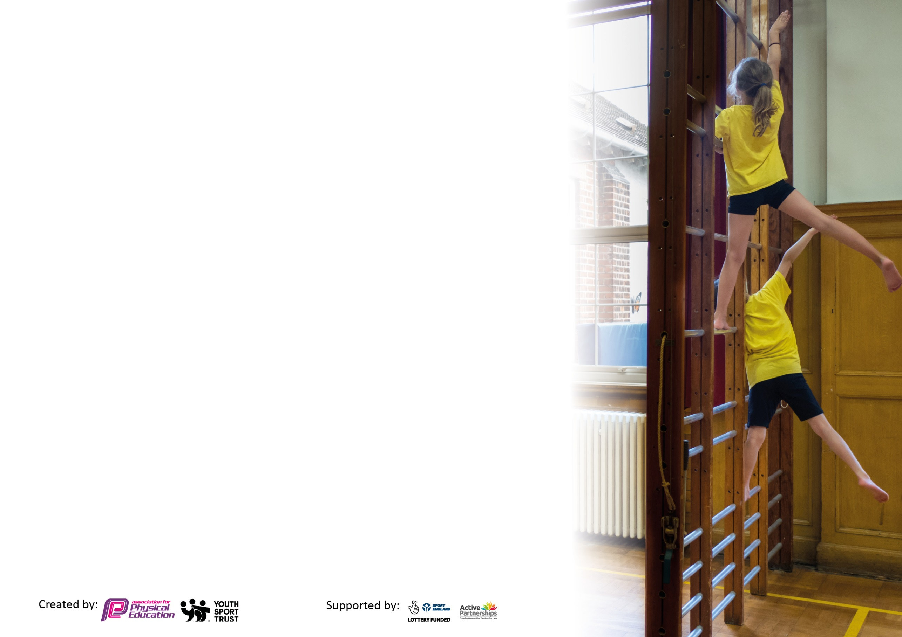
Please visit gov.uk for the revised DfE guidance including the 5 key indicators across which schools should demonstrate an improvement. This document will help you to review your provision and to report your spend. DfE encourages schools to use this template as an effective way of meeting the reporting requirements of the Primary PE and sport premium.

We recommend you start by reflecting on the impact of current provision and reviewing the previous spend.

Schools are required to publish details of how they spend this funding, including any under-spend from 2019/2020, as well as on the impact it has on pupils’ PE and sport participation and attainment by the end of the summer term or by 31st July 2021 at the latest.

We recommend regularly updating the table and publishing it on your website throughout the year. This evidences your ongoing self-evaluation of how you are using the funding to secure maximum, sustainable impact. Final copy must be posted on your website by the end of the academic year and no later than the 31st July 2021. To see an example of how to complete the table please click HERE.



Please note: Although there has been considerable disruption in 2020 it is important that you publish details on your website of how you spend the funding - this is a legal requirement.
Support for review and reflection - considering the 5 key indicators from DfE, what development needs are a priority for your setting and your pupils now and why? Use the space below to reflect on previous spend and key achievements and areas for development.

N.B. In this section you should refer to any adjustments you might have made due to Covid-19 and how these will influence further improvement.
Key achievements to date until July 2021: | Areas for further improvement and baseline evidence of need:
Key Indicator 1: Continuous provision for Sport and Activity provided during both periods of school closure.  - Senior Sports Coach delivered weekly PE/fitness sessions via uploaded videos.  - Other PE opportunities signposted e.g. Joe Wicks, wellbeing challenges.  - Key Worker Pupils in school completed the Daily Mile and had regular opportunities for active learning.  - Ongoing promotion of active learning and physical activity in lessons/daily mile/ through outdoor learning and Forest School to help recover lost fitness.  Key Indicator 4: Broader experience of a range of sports and activities offered to all pupils.  - Archery sets purchased for each bubble to introduce a new sporting opportunity during COVID restrictions.  - Extra-curricular clubs reintroduced to bubbles in Summer term 2021: Netball (Y5/6), Forest School (Y3/4), Mixed sport (Y3/4), Multisports (Y1/2) | Key indicator 1: Engaging all pupils in regular physical activity each day, particularly in light of increased behaviour issues following lockdowns. Pupils need short bursts of physical activity throughout the day.  Key indicator 4: To provide a broader range of sport offered to all pupils. Many sports have been limited for the past two years due to the ongoing impact of COVID, particularly team sports.  Key indicator 5: To increase participation in competitive sport-return to face-to-face competition following COVID disruption. Pupils have not been able to attend face to face competitions for nearly two years.

Did you carry forward an underspend from 2019-20 academic year into the current academic year? YES/NO * Delete as applicable
Total amount carried forward from 2019/2020 £3,370.99.
+ Total amount for this academic year 2020/2021 £16, 890
= Total to be spent by 31st July 2021 £20, 260.99
Meeting national curriculum requirements for swimming and water safety.

N.B Complete this section to your best ability. For example, you might have practised safe self-rescue techniques on dry land which you can transfer to the pool when school swimming restarts.
Due to exceptional circumstances priority should be given to ensuring that pupils can perform safe self-rescue even
if they do not fully meet the first two requirements of the NC programme of study.
What percentage of your current Year 6 cohort swim competently, confidently and proficiently over a distance of at least 25 metres?  N.B. Even though your pupils may swim in another year please report on their attainment on leaving primary school at the end of the summer term 2021.  Please see note above. | 100%
What percentage of your current Year 6 cohort use a range of strokes effectively [for example, front crawl, backstroke and breaststroke]?  Please see note above. | 100%
What percentage of your current Year 6 cohort perform safe self-rescue in different water-based situations? | 100%
Schools can choose to use the Primary PE and sport premium to provide additional provision for swimming but this must be for activity over and above the national curriculum requirements. Have you used it in this way? | Yes/No

Action Plan and Budget Tracking
Capture your intended annual spend against the 5 key indicators. Clarify the success criteria and evidence of impact that you intend to measure to evaluate for pupils today and for the future.

Academic Year: 2020/21 | Total fund allocated: £20, 260.99 (includes underspend from 19-20) | Date Updated: July 2021
Key indicator 1: The engagement of all pupils in regular physical activity – Chief Medical Officers guidelines recommend that primary school pupils undertake at least 30 minutes of physical activity a day in school |  |  |  | Percentage of total allocation:
 |  |  |  | 97%
Intent | Implementation |  | Impact
Your school focus should be clear what you want the pupils to know and be able to do and about  what they need to learn and to  consolidate through practice: | Make sure your actions to achieve are linked to your intentions: | Funding allocated: | Evidence of impact: what do pupils now know and what can they now do? What has changed?: | Sustainability and suggested next steps:
Provide a range of physical activity through membership of the Hertford and Ware School Sports Partnership | - Engagement with new partnership (as we have moved from another one to HWSPP) | £1,081  (+£1600 for next year to be paid for using funding underspend)  £2681 | - Membership of the partnership will enable improvements across all indicators due to the range of coverage including CPD, festivals. competitions, subject leader networking opportunities, sport-specific coaching and teacher and teaching assistant CPD. NB: Some provision interrupted by COVID, possible rebate coming from Partnership | - HWSSP membership next year due to be similar with cost of this year. This is budgeted for as part of the whole school budget.
To recover lost physical fitness caused by the lockdown in 2020 (NB this target has been disrupted due to the further lockdown in Spring 2021) | - Focus on health-related exercise and general fitness as part of the ‘recovery curriculum’ for PE in Autumn 2020.  - Further engagement in the Daily Mile-Weekly scores recorded and displayed on Sports noticeboard to promote the notion of personal challenge.  - Purchase new ‘easy clean’ individual PE mats to be used in gymnastics, yoga etc. | 32 xPE mats-TTS  £503.68 | - Pupils have worked on their personal fitness and improved stamina. EVIDENCE: Daily Mile scores recorded and displayed on Sports Board in Dining Hall.  - Daily Mile a daily occurrence for key worker bubble during Spring 2021 lockdown. This helped to promote physical and mental wellbeing during a difficult period.  - All pupils engaged in HRE during the Autumn Term. EVIDENCE: PE Planning file | - Continue to build of fitness development next academic year.  - Use new mats to introduce weekly yoga/fitness.
Enhance the physical and mental health and emotional well-being of learners through provision for Level 3 Forest School Teacher to enable high quality, active outdoor learning sessions across the school. | - EB/ LH to deliver high quality Forest School sessions to every class across the school year.  - MH to complete Level 3 Forest School training  - EB/LH run after school Forest School club when COVID restrictions allow (2 bubbles, Summer term 2021 Year 3/4, followed by Y5/6)  - EH/LH write a progressive scheme of work for Forest School (EYFS-Year 6) | EB salary-1/2 pw-£4,242.31 | - Increased physical activity during school day.  - More children achieving the 60mins of activity per day through access to Forest School Club. EVIDENCE: Forest school club register, Survey of physical activity sent via Microsoft Forms (part of parent Q)  - Children are more confident in using the terminology: ‘teamwork’ ‘resilience’ ‘perseverance’ and ‘confidence’ EVIDENCE: Forest School Scrapbook evidencing progress in character education. Forest School Photos. Pupil progress has been tracked via an assessment framework (wellbeing and skills)-See observation forms. Cohort trackers developed to track long term progression. | - St Thomas will be offering Forest School Enrichment days and training to other schools (Rearranged for Autumn term 2021 due to COVID related postponements). This will be a source of income. Money will be reinvested into our own Forest School provision to promote active learning.  - Planned staff CPD to be led in house by our level 3 practitioners.  - Staff meeting planned to go through planning etc.  - As part of transition into the St Francis of Assisi Academy trust-opportunities to deliver across the academy schools.
To lead playground sports and games ensuring that playtimes are active for all children. One additional MSA to be employed as a play leader. (Focus on one bubble while COVID restrictions in place) | - MSA to plan and organise playtimes with support from PE lead/Senior Sports Coach.  - MSA attend relevant training where possible and appropriate.  - MSA to also attend some sports festivals held by the HWSSP as CPD. NB: No festivals held this year due to COVID  - MSA to ensure that needs of target groups of children are being met during playtimes e.g. SEND | Play leader salary- £2,500 | - This will ensure that our lunchtime playground provision is high quality and meets the needs of all children within the school.  - Active playtimes will improve all children’s physical health, agility, coordination as well as social skills and mental health.  - Play leader MSA to provide training to other staff to allow for engagement in different activities for playtime bubbles in line with Covid 19 guidelines | - MSA Play Leader to upskill fellow MSAs
Sports Committee members trained as Play Leaders to support leadership and play opportunities for all pupils. *Stick within own bubbles or record videos to avoid crossing of bubbles during COVID restrictions | - Source Leadership training through HWSSP in the Autumn Term. | Part of HWSPP membership cost (see above) | - Sports Committee Members are confident in leading playtime games leading to an increase in physical activity.  - Play leaders will develop improved leadership skills, organisation, confidence and promote and spread their love of physical activity. | - Play leaders can pass on skills to younger members of the Sports Committee
(Intention added in light of Lockdown and School Closure as of January 2021)  To maintain engagement in physical activity despite national lockdown. To push the concept of personal challenge. | - Senior Sports Coach to record weekly Sports/fitness video challenges for children to access during home learning.  - Additional TA support to help pupils achieve maximum potential in PE lessons (particularly SEN) | Sports Coach salary-£7,392  Additional TA support in PE lessons for SEN pupils-£2,260 (6 hours per week) | - Personal challenge was planned for and promoted during the school closure period through LF’s PE sessions-each included 3 levels of challenge so were differentiated effectively. EVIDENCE: See uploaded sessions on Teams/Tapestry and relevant pupil engagement | - Personal challenge to be continued next year to further build resilience and perseverance. LF to plan in opportunities
Key indicator 2: The profile of PESSPA being raised across the school as a tool for whole school improvement |  |  |  | Percentage of total allocation:
 |  |  |  | 0%
Intent | Implementation |  | Impact
Your school focus should be clear what you want the pupils to know and be able to do and about  what they need to learn and to  consolidate through practice: | Make sure your actions to achieve are linked to your intentions: | Funding allocated: | Evidence of impact: what do pupils now know and what can they now do? What has changed?: | Sustainability and suggested next steps:
To celebrate Sporting Achievements at the end of the academic year 2020-21 to show that Sports has remained a high priority despite COVID restrictions. | - Plan a socially distanced Sports Day for July 2021, include medals and stickers based on the School Games Values. Celebrate effort and success with parents through shared video clips and pictures.  - LF nominate children from each class to receive end of term Sports awards.  - School Games Questionnaire to self-assess engagement despite covid | n/a | - Pupils all successfully took part in a Sports Day despite the restrictions still in place. Year 6 had an additional Sports afternoon that was attended by parents. EVIDENCE: Parent and Pupil Voice, photos of sports day | - If restrictions allow, return to a normal Sports Day format next year.

Key indicator 3: Increased confidence, knowledge and skills of all staff in teaching PE and sport |  |  |  | Percentage of total allocation:
 |  |  |  | 0%
Intent | Implementation |  | Impact
Your school focus should be clear | Make sure your actions to | Funding | Evidence of impact: what do | Sustainability and suggested
what you want the pupils to know | achieve are linked to your | allocated: | pupils now know and what | next steps:
and be able to do and about | intentions: |  | can they now do? What has
what they need to learn and to |  |  | changed?:
consolidate through practice:
Key indicator 4: Broader experience of a range of sports and activities offered to all pupils |  |  |  | Percentage of total allocation:
 |  |  |  | 3%
Intent | Implementation |  | Impact
Your school focus should be clear | Make sure your actions to | Funding | Evidence of impact: what do | Sustainability and suggested
what you want the pupils to know | achieve are linked to your | allocated: | pupils now know and what | next steps:
and be able to do and about | intentions: |  | can they now do? What has
what they need to learn and to |  |  | changed?:
consolidate through practice:
To introduce a new sport aimed at engaging pupils of all abilities-Archery  To offer gymnastics to all pupils following return from lockdown. | - Purchase archery sets (1 per bubble)  - LF to delivery appropriate training  - Ensure equipment inspected and ready for Spring 2021-John Harrison | Archery sets £122  Inspection of equipment-£200, repair of gymnastics benches £100 | - Pupils have experienced a new Sport and were able to take part in virtual archery competitions. EVIDENCE: Pupil voice, Archery Competition Results  - Staff also competed their own Archery Competition and requested this to happen in the future/ EVIDENCE: Staff wellbeing survey | - Build in further opportunities to use the archery sets next year.
Key indicator 5: Increased participation in competitive sport |  |  |  | Percentage of total allocation:
 |  |  |  | 0%
Intent | Implementation |  | Impact
Your school focus should be clear | Make sure your actions to | Funding | Evidence of impact: what do | Sustainability and suggested
what you want the pupils to know | achieve are linked to your | allocated: | pupils now know and what | next steps:
and be able to do and about | intentions: |  | can they now do? What has
what they need to learn and to |  |  | changed?:
consolidate through practice:
Senior Sports Coach deployed to implement virtual competitions during COVID restrictions. Pupil participation in the School Games will be increased despite the lack of face-to-face competition. | - LF to coordinate virtual competitions throughout the year whilst face to face competition unable to happen. (To date: Archery, Speed stacking, Football and Boccia engaged with in the Autumn term. Rapid Fire Cricket (Y3/4) and Sports Hall Athletics (Y3/4 and Y5/6) planned for Summer term) | LF salary-see key indicator 1 | - All KS2 have participated in some form of virtual competition this academic year. EVIDENCE: Competition Results, School Games Dashboard, School Games Questionnaire | - Return to face-to-face competition scheduled for Autumn 2021  - Plan a mini competition for KS1 led by KS2 Sports Leader

Signed off by
Head Teacher: | Michelle Keating
Date: | 20th July 2021
Subject Leader: | Wendy Clark
Date: | 20th July 2021
Governor: | Mary Lennon
Date: | 20th July 2021

