
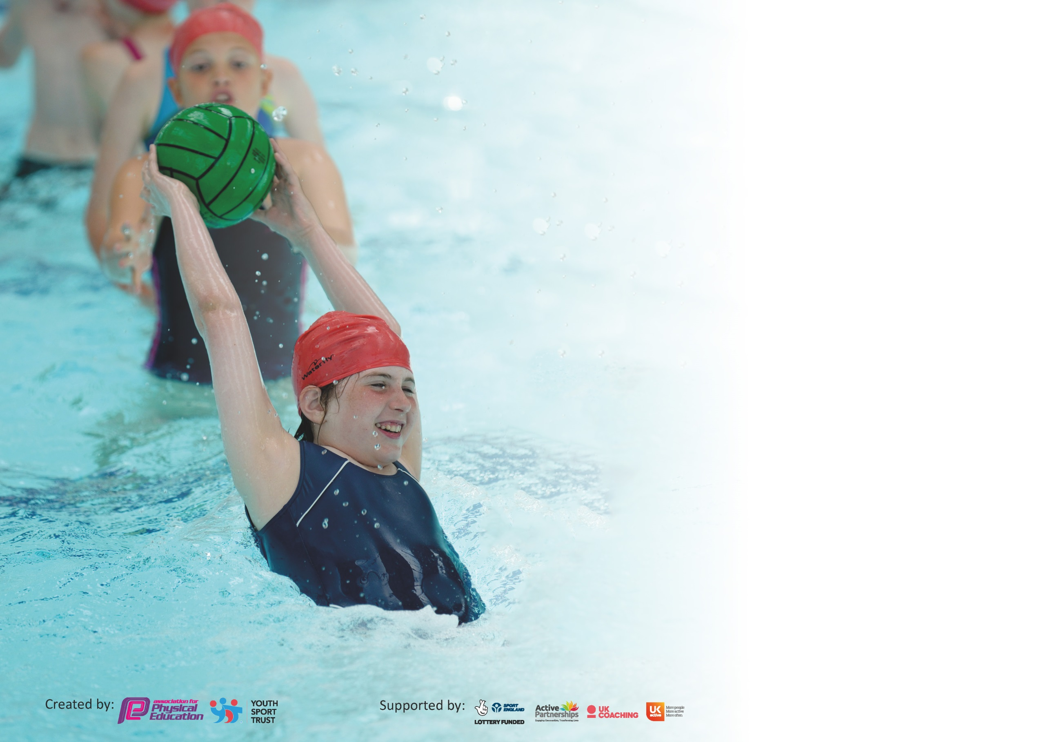

It is important that your grant is used effectively and based on school need. The Education Inspection Framework (Ofsted 2019 p64) makes clear there will be a focus on ‘whether leaders and those responsible for governors all understand their respective roles and perform these in a way that enhances the effectiveness of the school’.

Under the Quality of Education criteria (p41) inspectors consider the extent to which schools can articulate their curriculum (INTENT), construct their curriculum (IMPLEMENTATION) and demonstrate the outcomes which result (IMPACT).

To assist schools with common transferable language this template has been developed to utilise the same three headings which should make your plans easily transferable between working documents.

Schools must use the funding to make additional and sustainable improvements to the quality of Physical Education, School Sport and Physical Activity (PESSPA) they offer. This means that you should
use the Primary PE and Sport Premium to:

- Develop or add to the PESSPA activities that your school already offer
- Build capacity and capability within the school to ensure that improvements made now will benefit pupils joining the school in future years

Please visit gov.uk for the revised DfE guidance including the 5 key indicators across which schools should demonstrate an improvement. This document will help you to review your provision and to report your spend. DfE encourages schools to use this template as an effective way of meeting the reporting requirements of the Primary PE and Sport Premium.

We recommend you start by reflecting on the impact of current provision and reviewing the previous spend.

Schools are required to publish details of how they spend this funding as well as on the impact it has on pupils’ PE and sport participation and attainment by the end of the summer term or by 31st July 2020 at the latest.

We recommend regularly updating the table and publishing it on your website throughout the year. This evidences your ongoing self-evaluation of how you are using the funding to secure maximum, sustainable impact. Final copy must be posted on your website by the end of the academic year and no later than the 31st July 2020. To see an example of how to complete the table please click HERE.

Support for review and reflection - considering the 5 key indicators from DfE, what development needs are a priority for your setting and your pupils now and why? Use the space below to reflect on previous spend and key achievements and areas for development.

Key achievements to date until July 2019: | Areas for further improvement and baseline evidence of need:
- Regular sporting achievements  - Achieving Gold School Games Mark for 2018/19  - High profile PE and sport across the school for all year groups  - Many pupils sharing their sporting achievements from outside school e.g. National Level tennis, cheerleading and gymnastic awards from National competitions  - Introduction and embedding of a ‘Weekly Mile’ improving overall pupil fitness and concentration alongside helping pupils with the concept of personal challenge  - Introduction and embedding of ‘Forest School’ giving all learners access to active learning in the curriculum, promoting good physical health and emotional wellbeing  - New MUGA in daily use break, lunchtimes, PE and sports clubs  - Increase in opportunities for pupils to lead in games e.g. all Year 5/6 were used as Sports Leaders when hosting KS1 Multiskills Festivals  - All pupils from Year 1-4 have timetabled swimming lessons (at least 12 lessons per year) | - To further improve the range of extra-curricular clubs to engage the less active pupils (including Forest School after school club throughout the year, netball, football)  - Provision and tracking of more structured activities for break and lunchtime to increase engagement with physical activity

Meeting national curriculum requirements for swimming and water safety.
What percentage of your current Year 6 cohort swim competently, confidently and proficiently over a distance of at least 25 metres?  N.B. Even though your pupils may swim in another year please report on their attainment on leaving  primary school at the end of the summer term 2020. | 100%
What percentage of your current Year 6 cohort use a range of strokes effectively [for example, front crawl, backstroke and breaststroke]? | 73%
What percentage of your current Year 6 cohort perform safe self-rescue in different water-based situations? | 100%
Schools can choose to use the Primary PE and Sport Premium to provide additional provision for swimming but this must be for activity over and above the national curriculum requirements. Have you used it in this way? | No

Action Plan and Budget Tracking
Capture your intended annual spend against the 5 key indicators. Clarify the success criteria and evidence of impact that you intend to measure to evaluate for pupils today and for the future.

Academic Year: 2018/19 | Total fund allocated: £ ​16,920  Actual spend: £13,549.01  £3,370.99 to be carried over to the next academic year due to MSA play leader recruitment and payment for Sports Partnership being deferred due to Coronavirus lockdown. | Date Updated: 30th July 2020
Key indicator 1: The engagement of all pupils in regular physical activity – Chief Medical Officer guidelines recommend that primary school pupils undertake at least 30 minutes of physical activity a day in school |  |  |  | Percentage of total allocation:
 |  |  |  | 31%
Intent | Implementation |  | Impact
Your school focus should be clear what you want the pupils to know and be able to do and about  what they need to learn and to  consolidate through practice: | Make sure your actions to achieve are linked to your intentions: | Funding allocated: | Evidence of impact: what do pupils now know and what can they now do? What has changed?: | Sustainability and suggested next steps:
To further embed Forest School into  the whole school curriculum promoting active learning and helping all children to achieve at least 30 minutes active learning across the school day. | EB to complete modules for  Level 3 Forest School  Training by February 2020  (funded from Sport’s  premium 2017/18)  GP to complete Forest School Training by May 2020.  LH to complete modules for  Level 3 Forest School Training by February 2020 (funded from 2019/20). Accreditation received May 2020  MH to complete Level 3 Forest School Training by July 2021 (funded from 2019/20 and 2020/21)  All classes to have Forest  School sessions for one full  term within the academic  year (Early Years every week). Programme disrupted due to Lockdown. EY, Year 1, Keyworker and Year 6 bubbles had some Forest School provision when in school.  To operate an extracurricular Forest School club throughout the year to further increase active learning opportunities. | LH Forest School Level 3 Training: £1,025  GP Forest School Level 2 Training: £660.00  MH Forest School Level 3 (plus First Aid) Training: £999.00 | - Highly trained staff that can deliver quality Forest School provision across the whole school.  - Children are more confident in using the terminology: ‘teamwork’ ‘resilience’ ‘perseverance’ and ‘confidence’-This will need to be reinforced due to disruption in the Forest School programme due to lockdown. EVIDENCE: Forest School Scrapbook evidencing progress in character education. Pupil progress has been tracked via a 1-4 scale.  - Year 6 had a final forest school day on their last day at St Thomas’ (15/07/2020). This was a well needed boost to emotional wellbeing following the stresses of the Lockdown period due to Coronavirus. They were able to communicate and negotiate with peers and adults to solve problems and share experiences (den building). EVIDENCE: Photo on web. Year 6 exit interviews?  - Forest School Club ran successfully during the Autumn Term. EVIDENCE: Clubs registers. | - Further embed progress tracking in Forest School.  - St Thomas will be offering Forest School Enrichment days and training to other schools (Some schools had booked this for Summer 2020-deferred to Autumn 2020 due to Coronavirus). This will be a source of income. Money will be reinvested into our own Forest School provision to promote active learning.
To continue to embed the Weekly  Mile for Years 1-6, increasing overall  activity levels. | Maximising use of new MUGA (installed 2018) to allow each year group a focussed/directed Weekly  Mile session plus ample opportunities for all children to access the MUGA throughout the week in lessons and break times to further engage with activity.  Further development of growth mindset to promote the notion of personal challenge and self-improvement. | Growth Mindset additional resources: £180.00 | - Weekly scores recorded and displayed on Sports noticeboard to promote the notion of personal challenge.  - Daily Mile a daily occurrence for key worker bubble during their time in school. This helped to promote physical and mental wellbeing during a difficult period.  - MUGA used for a range of sports and activities, enabling more experiences for children at breaks and lunchtimes and PE lessons  - Personal challenge was planned for and promoted during the school closure period through LF’s PE sessions-each included 3 levels of challenge so were differentiated effectively. EVIDENCE: PE video lessons on Tapestry and Purple Mash | - Focus on health-related exercise and general fitness as part of the ‘recovery curriculum’ for PE in Autumn 2020. The Daily Mile will be a key feature of this.  - Create a survey to gauge daily activity including PE, School Sport and other daily exercise. Use to inform planning for next year.
To increase activity levels through  playground leaders and introduction of new equipment.  To employ an additional MSA to encourage active play and support the play leaders in the delivery of planned activities. | LF to work with Sports Committee to structure playground activities – leaders to be identifiable | Cost for MSA: Approx £2,500.00 (recruitment deferred due to Coronavirus-carry over to September) | - Sports Committee have been effective this year and were higher profile in the school.  - Sports Committee participated in whole school assemblies promoting ‘Game of the Month’ and other events.  - Highly successful Skip2Bfit event which the Sports Committee were involved in organising and promoting. The funds raised are ready to be used for PE resources for next academic year. | - Reinvest money raised by Skip2Bfit event-purchase equipment for playground activities.
Key indicator 2: The profile of PESSPA being raised across the school as a tool for whole school improvement |  |  |  | Percentage of total allocation:
 |  |  |  | 0%
Intent | Implementation |  | Impact
Your school focus should be clear what you want the pupils to know and be able to do and about  what they need to learn and to  consolidate through practice: | Make sure your actions to achieve are linked to your intentions: | Funding allocated: | Evidence of impact: what do pupils now know and what can they now do? What has changed?: | Sustainability and suggested next steps:
To retain the School Games gold award while continuing to demonstrate a high level of PE coverage throughout the school. | LF to have leadership time to complete application for Gold award for the academic year 2019/20 | n/a | - School Games Mark application suspended due to Coronavirus therefore existing Gold maintained. Virtual School Games Mark also achieved to recognise our efforts in offering virtual Intra competition during lockdown (kick rounders competition for key worker ‘bubble’, whole school virtual sports week-activities set via video for access at home or school) | - Aim to maintain Gold Award next academic year. LF/WC work on together during the academic year.

Key indicator 3: Increased confidence, knowledge and skills of all staff in teaching PE and sport |  |  |  | Percentage of total allocation:
 |  |  |  | 2%
Intent | Implementation |  | Impact
Your school focus should be clear | Make sure your actions to | Funding | Evidence of impact: what do | Sustainability and suggested
what you want the pupils to know | achieve are linked to your | allocated: | pupils now know and what | next steps:
and be able to do and about | intentions: |  | can they now do? What has
what they need to learn and to |  |  | changed?:
consolidate through practice:
PE coordinator to attend annual PE conference to in turn enhance the confidence, knowledge and skills of the rest of the staff. | WC attend PE conference in January 2020. | PE conference fee: £150 plus £180 (KIT payment as Coordinator on Maternity Leave) | - Sports Premium Policy updated.  - Core learning from CPD ‘Physical Activity in the Playground’ to be disseminated to staff by PE coordinator to help increase activity at break and lunch. Deferred to Coronavirus. EVIDENCE: CPD records. Observations/learning walks at break and lunchtime. | - WC lead relevant CPD next academic year.
Key indicator 4: Broader experience of a range of sports and activities offered to all pupils |  |  |  | Percentage of total allocation:
 |  |  |  | 1%
Intent | Implementation |  | Impact
Your school focus should be clear | Make sure your actions to | Funding | Evidence of impact: what do | Sustainability and suggested
what you want the pupils to know | achieve are linked to your | allocated: | pupils now know and what | next steps:
and be able to do and about | intentions: |  | can they now do? What has
what they need to learn and to |  |  | changed?:
consolidate through practice:
To embed the Forest School after school club aimed at enhancing  wellbeing and overall activity levels.  Specialist coaching for Tag Rugby | To operate an extracurricular Forest School club throughout the year to further increase active learning opportunities.  Bring in specialist coach for Tag Rugby to broaden children’s experiences and upskill staff. | Forest School training for staff (see Key Indicator 1)  Tag Rugby Coaching: £225.00 | - Improved Mental Health and Wellbeing across the school. Improved academic results. EVIDENCE: Pupil and parent questionnaires (deferred due to Coronavirus)  - Pupils develop skills in Tag Rugby and become more confident with the rules of the game. EVIDENCE: Pupil voice, parent questionnaires (deferred due to Coronavirus) | - Payment from parents for club reinvested into Forest School Club and resources

Key indicator 5: Increased participation in competitive sport |  |  |  | Percentage of total allocation:
 |  |  |  | 66%
Intent | Implementation |  | Impact
Your school focus should be clear | Make sure your actions to | Funding | Evidence of impact: what do | Sustainability and suggested
what you want the pupils to know | achieve are linked to your | allocated: | pupils now know and what | next steps:
and be able to do and about | intentions: |  | can they now do? What has
what they need to learn and to |  |  | changed?:
consolidate through practice:
To further increase the number of  competitions we attend and to increase the level of success in these  particularly with respect to recent changes in the local Sports Partnership  Increased participation at Level 1 and  Level 2 competitions | To organise and run more  local competitions from St  Thomas’ (Responsibility of Senior Sports Coach)  Quality coaching for football team.  Enter a local league for football and/or netball-Plans disrupted due to Coronavirus | Salary for Senior Sports Coach: £9,903.53 per annum  New footballs to facilitate team training and competitions £135.55  New electric pumps for upkeep of balls: £100.48  Fee for Sports Partnership: £1,040 (not charged this academic year due to Covid-payment due September) | - Pupils take part in more sports competitions across an academic year. Fewer non-participants in competitive sport. EVIDENCE: Registers from attendance at competitive events. Any awards gained. Photos on website. Match results from Thomas Tigers. Fixtures disrupted due to Coronavirus.  - Children’s sporting achievements celebrated in whole school assembly and via the PE/Sport notice board in the dining room.  - Virtual School Games Mark achieved to recognise our efforts in offering virtual ‘intra’ (level 1) competition during lockdown (kick rounders competition for key worker ‘bubble’, whole school virtual sports week-activities set via video for access at home or school)  - Many events cancelled due to coronavirus. | - Move to HWSSP from Autumn 2020.This will provide more relevant competitive opportunities against schools of a similar nature.  - Use pupil voice to find out which other competitions children would like to be part of.

Signed off by
Head Teacher: | Michelle Keating
Date: | July 2020
Subject Leader: | Wendy Clark
Date: | July 2020
Governor: | Mary Lennon
Date: | July 2020

