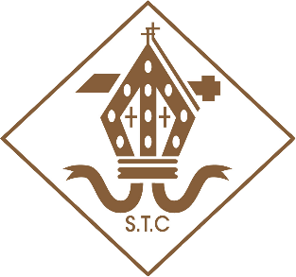
ST THOMAS OF CANTERBURY PTA

STOC PTA Charter

The STOC PTA’s role is not only that of fundraising for the school; our role is wider than that and has the wellbeing and education of the children attending the school at the centre of all that we do.

Mission Statement

STOC PTA aim to enhance the education of the pupils by:

- Developing more extended and effective relationships between the staff, parents and others associated with the school
- Engaging in activities which support the school by providing or assisting in the provision of facilities for education (not normally provided by the Local Education Authority)
- Arranging events and activities that raise funds for equipment and projects in school
- Organising social events for the enjoyment of the pupils, their families and friends, and the wider community

Terms of Reference

- The PTA must be consulted and agreement confirmed prior to any funds generated by PTA activities or events being used by the school

- PTA funds should be used for projects and equipment that benefit the entire school rather than only one particular year group; exceptions may apply with prior agreement from the PTA
- PTA funds should, wherever possible, be used to fund legacy projects and equipment; i.e. those that will be used for many years and enrich the school life of pupils for the future
- A maximum of two single events (i.e. author visits, science workshops, etc.) which benefit the whole school, may be funded by the PTA by agreement at the beginning of the school year, if funds are available
- The PTA commit to donating a maximum of 10% of the previous year’s fundraising total towards the school building fund, if the funds are available
- Written confirmation of full costs for any project must be sent to the PTA chair prior to funds being made available

