

St Thomas of Canterbury Catholic Primary School
Executive Headteacher: Mrs M Keating
Acting Head of School: Mrs W Clark

12th September 2025

Dear Parents and Carers,

A warm welcome back to school to all families, especially those who are new to St Thomas’. We hope you have all enjoyed the lovely weather we have had over the summer! Please see the information below for this half term’s staffing and curriculum in the Early Years.

 | Monday | Tuesday | Wednesday | Thursday | Friday
Staffing | Mrs Overett (Class Teacher)  Mrs Smith (Teaching Assistant)  Mrs Healy (Teaching Assistant)  Ms Roux  (Learning Support Assistant) | Mrs Clark (Class Teacher)  Mrs Smith (Teaching Assistant-AM)  Mrs Scher (Teaching Assistant)  Mrs Healy (Teaching Assistant-PM)  Ms Roux (Learning Support Assistant) | Mrs Clark (Class Teacher)  Mrs Smith (Teaching Assistant-AM)  Mrs Scher (Teaching Assistant)  Mrs Healy (Teaching Assistant-PM)  Ms Roux (Learning Support Assistant) | Mrs Smith (Class Teacher)  Mrs Healy (Teaching Assistant)  Mrs Obi (Teaching Assistant)  Ms Roux (Learning Support Assistant) | Mrs Overett (Class Teacher)  Mrs Smith (Teaching Assistant)  Ms Roux (Learning Support Assistant)
⃰Parent volunteers are always welcome in the Early Years class. This term in particular we are looking for volunteers to read a favourite story to the children. Please contact a member of the team if you think you can help!

Curriculum Information - Topics
Autumn 1 2025 | Autumn 2 2025 | Spring 1 2026 | Spring 2 2026 | Summer 1 2026 | Summer 2 2026
Who Am I and Who Are You? | Celebrations! | Out of This World! | Treasure | Wild World | Them Bones, Them Bones
Reading days – More information to follow
All Parents are welcome to celebrate our Early Years Harvest Act of Worship with us on 9th October 2025 at 9.15am. Further details to follow.
We will be holding a Phonics Information Meeting in the Early Years Classroom on 23rd September at 3.30pm. This is a chance for you to understand the Phonics learning that your child will be covering throughout their Reception year and beyond.
Autumn 1 Curriculum
Curriculum Area | Nursery & Reception | Home Enrichment Activities
Personal, Social and Emotional Development | Children will have the opportunity to share their thoughts and feelings in circle time. Children will be encouraged to talk about their likes and dislikes and begin to identify similarities and differences between themselves and others. Children will get to know our class rules and routines. We use visuals, similar to those below, to help the children understand class behaviour expectations.  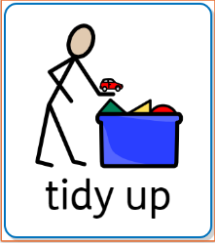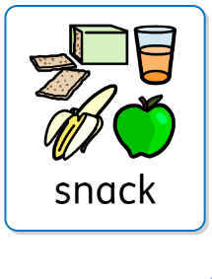 | Reinforce expected behaviour in the home setting. Discuss the consequences of inappropriate behaviour/actions. Talk about feelings with your child and help them to understand: happy, sad, angry and scared. Encourage them to express how they might be feeling.  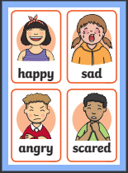
Physical Development | Children will access the outdoor classroom, and develop balance and coordination skills to enable them to travel in a variety of ways, including over, under, through and around obstacle and climbing equipment. Reception pupils will take part in PE in the school hall, playground or field. Children will engage in a variety of fine motor control activities including: threading, construction, mark making and dough activities, all of which help to develop strength and dexterity for pencil control. Children will practise health and self-care routines including: hand washing, blowing their nose and dressing for PE and the outdoor environment. | Encourage your child to be fully proficient when using the toilet and washing their hands.  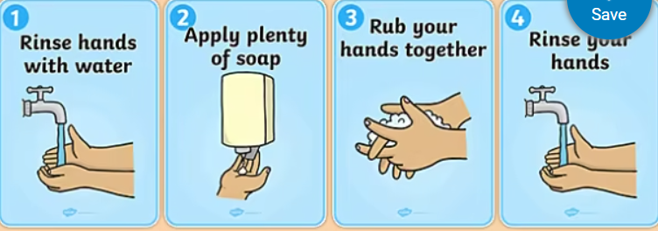  Support children to develop the ability to cope with dressing and undressing such as putting on shoes independently, or having a go at doing up zips.
Communication and Language  Literacy | Children will be encouraged to take part in circle time activities within small groups and whole class. There will be lots of opportunities for pupils to express their views, share stories and become confident to speak in a familiar group. We promote Oracy skills through all learning that takes place (Speaking clearly, Listening to others, Asking questions, Developing answers). Children will have the opportunity to engage in role play to develop their expressive language. Language intervention will be delivered to target pupils to develop their expressive and receptive language and early language development. | Encourage your child to speak to a range of adults in the home setting. Encourage your child to ask and answer two part questions and instructions.  Discuss the songs we have been singing at school and encourage your child to make up their own songs.  Encourage your child to identify letters in the environment, e.g. number plates, signs, magazines etc.  Read a story to your child every day. Encourage your child to talk about the illustrations in the stories. Model how to hold a book correctly and turn pages. Feed your child’s imagination and deepen their vocabulary by telling them a range of stories  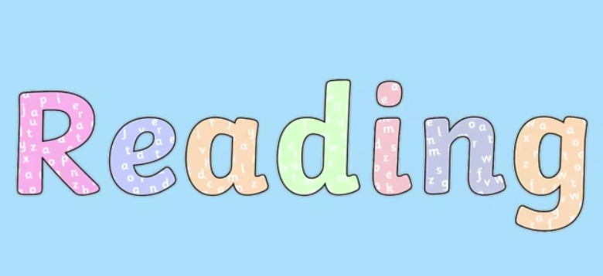
Mathematics | Children will be introduced to Numicon, which is a multi-sensory resource to support mathematical concepts, for example pattern and addition. Children will consolidate their understanding of the numbers 0-5; counting up to five objects accurately and matching to the correct numeral. Children will also develop their understanding of ‘one more’, find the total number of items in two groups by counting and begin to use the vocabulary involved in addition. Children will also explore patterns and sorting objects by different criteria. | Practise counting with your child. You might like to count objects in the home setting. Encourage your child to place objects in a line whilst counting and to touch count. Go on a ‘Number Hunt’ with your child, Draw their attention to numbers in the environment for example, on registration plates, buses, doors and encourage them to recognise and name the numerals they see.  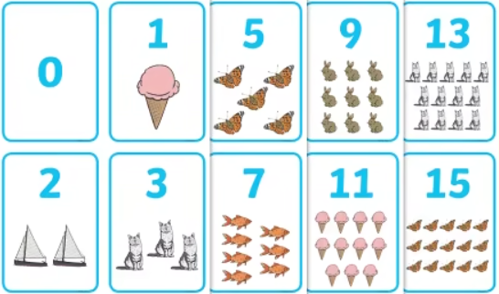  Please follow the links below for further information on Numicon or for educational games to access at home:  • Making Numbers Real-Numicon https://www.youtube.com/watch?v=yYgwM5Z1tMo  • Crickweb-free online educational games for children http://www.crickweb.co.uk/Early-Years.html  • Topmarks-free online Maths games for children https://www.topmarks.co.uk/maths-games/3-5-years/counting
Understanding of the World | Children will learn about themselves, and others and learn to recognise similarities and difference between us all. We will discuss our families, friends and what we enjoy as we get to know each other. We will also learn that we are all made equal in the image of God. Children will be learning about Harvest, Diwali and the build up to bonfire night. We will be noting the changes in seasons and what they can see is changing around them. Children will learn about Staying Healthy including dental and hand hygiene. | Discuss families and extended family, perhaps draw a picture of these to share with us at school, or bring in a photo! Encourage your child to observe and describe the signs of Autumn. Collect fallen leaves and allow your child to produce leaf collage pictures. Your child may like to bring fallen Autumnal leaves to school.  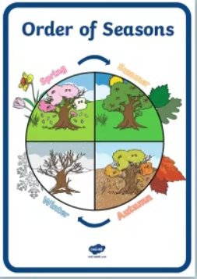
Expressive Arts and Design | Children will explore drawing techniques and will begin to use different types of materials to produce art work (paint, college, clay, playdough and pastel) During child initiated learning children will have access to a wide variety of creative materials and will be able to express their own creativity. Children will be able to access a variety of small world and role play activities to develop expressive language. Children will develop their repertoire of Nursery Rhymes, Action Songs and themed songs. They will develop an understanding of rhythm and beat within music as well as pitch. | Encourage your child to sing songs from school in the home setting. Allow your child to access a wide range of creative activities: painting, collage, creative role play etc. Why not make a Leaf Man with your child?  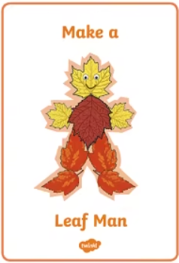
Religious Education | Our R.E topic this half term is Creation and Covenant.  Children will learn how to make the Sign of the Cross and join in with our daily class prayers.  Children will learn about the things God created and ways to take care of these.  Children will learn that God has made us all unique and that we all share similarities and differences. Children will learn that God loves every one of us. | Encourage children to point out the things God made in the world (plants, animals, the sun, moon etc.) You could also share the Bible Creation Story together (Genesis 1: 1-2 and 3)  Maybe your child would like to bring in a photo of your pet if you have one and talk to us about how they take care of their pet.  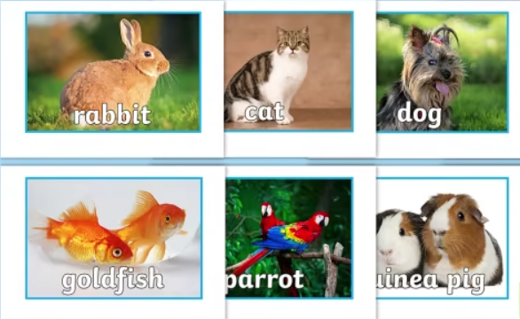
Please send in a pair of welly boots and a cycle helmet (both clearly named) for your child to use in school. You may also like to provide a change of clothes in a named bag in case of toileting accidents or muddy weather. Please ensure all water bottles and lunchboxes are clearly named. Water is available throughout the day and your child will be offered a healthy snack each morning. Please ensure there are NO NUT PRODUCTS brought to school as we have children with severe allergies.
P.E kits will need to remain in school at all times ready for P.E every Friday for Reception from Friday 5th September. Nursery will begin their P.E sessions on a Friday once settled, usually this is after the October half term but we will confirm nearer the time. Nursery will also need to leave their P.E kits at school once their sessions begin. All P.E kits will be sent home regularly for washing.
We will use Tapestry to communicate any Home Learning Tasks or minor incidents that might happen during the school day. Please ensure you have followed the link sent to your email address to activate your Tapestry account (new starters only). We are unable to use Tapestry until you have activated your account.
If you have any questions please feel free to catch us at drop off or collection times and we will be happy to make an appointment to discuss all queries or concerns. Alternatively, please direct any questions via email to emma.overett@stcanterbury.herts.sch.uk or katie.mills@stcanterbury.herts.sch.uk and a member of the Early Years Team will get back to you.
We look forward to a busy and exciting term ahead!
The Early Years Team

