St Thomas of Canterbury Catholic Primary School
Headteacher: Mrs M Keating
“Learn, Love and Respect Through Jesus” St Francis of Assisi

CATHOLIC ACADEMY TRUST

19th April 2024

Dear Parents and Carers,
A warm welcome back to school to all families, we hope you had a restful and happy Easter. This term’s topics are ‘Wild World’ and ‘Them bones, Them bones’. Please see the information below for this half term’s staffing and curriculum in the Early Years.
 | Monday | Tuesday | Wednesday | Thursday | Friday
Staffing | Mrs Overett (Class Teacher)  Mrs Smith  (Teaching Assistant)  Mrs Healy (Teaching Assistant) | Mrs Clark (Class Teacher)  Mrs Scher  (Teaching Assistant)  Mrs Healy (Teaching Assistant ) | Mrs Clark (Class Teacher)  Mrs Scher  (Teaching Assistant)  Mrs Healy (Teaching Assistant) | Mrs Overett (Class Teacher)  Mrs Smith  (Teaching Assistant)  Mrs Healy (Teaching Assistant) | Mrs Overett (Class Teacher)  Mrs Scher  (Teaching Assistant - AM)  Mrs Smith (Teaching Assistant)

This term we will be welcoming Father John back into school for our class prayer service on 25th June at 2.45pm. We hope that you can join us for this very special service.
Curriculum Information - Topics
Autumn 1 2023 | Autumn 2 2023 | Spring 1 2024 | Spring 2 2024 | Summer 1 2024 | Summer 2 2024
Who am I and Who are You? | Celebrations! | Out of this World | Treasure | Wild World | Them bones, them bones
Below we have highlighted some of the key learning intentions for the beginning of the Summer Term, however please note these are not exhaustive and will be adjusted and adapted to suit the needs of individual children and the entire cohort.
Summer 1 Curriculum
Curriculum Area | Nursery & Reception | Home Enrichment Activities
Personal, Social and Emotional Development | To understand some ways in which we can look after our world and why this is important.  To develop their sense of unique self by talking about similarities and differences to others.  To think about the perspectives of others.  To explain how they can demonstrate friendly behaviour.  To manage their own needs. | Reinforce expected behaviour in the home setting. Discuss the consequences of inappropriate behaviour/actions. Play turn taking games and reinforce that winning and losing are both okay. Talk about feelings with your child and help them to understand: happy, sad, angry and scared. Encourage them to express how they might be feeling.  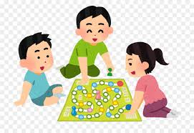
Physical Development | The children will learn to assess risks involved in using hammers and nails and they will develop safety awareness, balance and coordination skills to enable them to travel in a variety of ways, including over, under, through and around obstacle equipment. Children will continue to engage in a variety of fine motor control activities including: scissor control, threading, construction, mark making and dough activities. We will support all children to develop their pencil grip and pencil control further. | Encourage your child to dress and undress independently wherever possible including having a go at zips on coats and Velcro shoe straps or buckles.  Support your child in assessing and taking appropriate risks such as using a new piece of playground apparatus at the park.  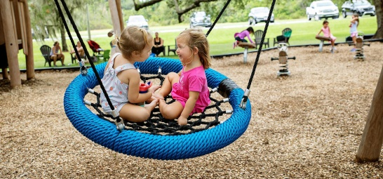  Encourage proficient and independent hand washing before snacks, meals or any food prep.
Communication and Language  Literacy | Children will continue to be encouraged to take part in circle time activities within small and large groups. There will continue to be lots of opportunities for pupils to express their views, share stories and become confident to speak in a familiar group and we will continue to support children in responding to ideas expressed by others with relevant comments and questions. Children will be encouraged to use talking to help work out problems and organise thoughts  Children will be introduced to a wide range of vocabulary linked to our Wild World topic, including wild, domestic, mammals, reptiles, birds, amphibians, invertebrates, vertebrates, habitat, features, nocturnal.  Wellcomm Language intervention will continue to be delivered to target pupils to develop their expressive and receptive language and early language development. | Encourage your child to have a go at labelling any pictures they draw or models they create. Other opportunities for writing at home include writing shopping lists, writing cards to family or friends, making tickets for shows or movie nights. It is fine for Nursery’s writing attempts to just be marks on paper!  Reception children will continue to bring home phonics sheets to help consolidate our phonics learning each week.  Read a story to your child every day. Encourage your child to talk about the illustrations in the stories. Model how to hold a book correctly and turn pages. Feed your child’s imagination and deepen their vocabulary by telling them a range of stories
Mathematics | Children in Nursery will be learning to count and recognise numbers from 5-10 and beyond if they are ready. They will also be using the language of space, size, distance and time sequence.  Children in Reception will become competent in subitising and counting on or back within 10. We will then develop understanding of tens and ones of teen numbers to 20. Children will use tens frames and number lines competently to solve mathematical problems. We will be working hard to consolidate our recall of number bonds to 10 as well as doubles facts, subtraction and addition. | Practise counting, sharing amounts between two groups and recognising numbers up to 20 with your child. Find opportunities to practice addition and subtraction up to 10.  You might like to go on a ‘Shape Hunt’ searching for and describing basic 2d (square, rectangle, triangle, circle) and 3d (sphere, pyramid, cone, cube, cuboid) shapes around your home.  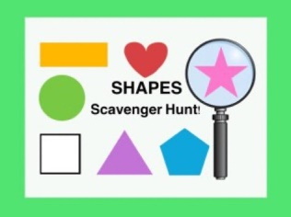
Understanding of the World | Children will be learning to sort animals according to their features. We will learn about the different types of animal (mammals, reptiles, birds, amphibians, invertebrates) and the features of their habitats.  We will also be learning to use a computer and a computer mouse to complete a simple programme such as painting a picture, and remembering how we stay safe online. | Go on walks and point out the changes that are taking place in the environment as we move towards summer.  Perhaps you can look for various habitats in the local area or in countries that you may have visited before.  Remind children of ways to stay safe online (not clicking on anything they don’t recognise, telling a grown up if they are unsure)
Expressive Arts and Design | Children will be taught a range of skills to help them develop confidence and enjoyment of expressive arts, from singing and dancing to selecting appropriate media and materials to create. | Allow children to explore creatively using tools such as paintbrushes, dabbers, sponges. Talk to them about their choices and creative ideas. Encourage creative role play and expression through music / singing.  Perhaps you can research an artist and share what you find on Tapestry? We’d love to hear from you!
Religious Education | Our R.E topic this half term is To the ends of the Earth.  Children will learn about the joy Jesus brought at Easter and about his Ascension to his Father in heaven. We will look for signs of new life in the beautiful world around us and thank God for these things. We will learn about the Holy Spirit and the apostles in the early church. | Go for a Summer walk to look for signs of new life such as flowers and baby animals growing.  Say prayers to thank God for the beautiful world he has created.
In line with our ‘Wild World’ topic, we are very excited to welcome an animal encounter experience into school in which the children will get to look at and hold various exotic and domestic animals. More details on this to follow.
Please continue to return reading books every Monday. A member of staff will take these out of the children’s bags and tick them off once received. Unfortunately if books are not returned, your child will not be able to take the following week’s book home to practise.
Forest School sessions will continue this term on Thursday afternoons. Please ensure your child has named welly boots and Forest School kit in school every Thursday. There may be occasions where other school events occur and Forest School sessions will not take place.
If you have any questions please feel free to catch us at drop off or collection times and we will be happy to make an appointment to discuss all queries or concerns.
We look forward to another busy and exciting term ahead!
Mrs Overett Mrs Clark
EYFS Teacher EYFS Teacher

