

ST THOMAS OF CANTERBURY CATHOLIC PRIMARY SCHOOL

High Street, Puckeridge, Herts SG11 1RZ

Tel: 01920 821450

Headteacher: Mrs Michelle Keating BEd (Hons) Website: www.stcanterbury.herts.sch.uk
Assistant Head: Mr Andrew Booth BSc (Hons) E-Mail: admin@stcanterbury.herts.sch.uk

Dear Parents and Carers,

A warm welcome back to school to all families, especially those who are new to St Thomas’. We are very excited to get to know the children this term and begin our learning journey with them! Please see the information below for this half term’s staffing and curriculum in the Early Years.

 | Monday | Tuesday | Wednesday | Thursday | Friday
Staffing | Mrs Overett (Class Teacher)  Mrs Scher (Teaching Assistant)  Mrs Healy (Teaching Assistant) | Mrs Clark (Class Teacher)  Mrs Scher (Teaching Assistant)  Mrs Smith (Teaching Assistant- AM)  Mrs Healy (Teaching Assistant - PM) | Mrs Clark (Class Teacher)  Mrs Scher  (Teaching Assistant)  Mrs Healy  (Teaching Assistant) | Mrs Overett (Class Teacher)  Mrs Scher  (Teaching Assistant)  Mrs Smith  (Teaching Assistant)  Mrs Healy (Teaching Assistant) | Mrs Overett (Class Teacher)  Mrs Smith  (Teaching Assistant)
⃰Parent volunteers are always welcome in the Early Years class. This term in particular we are looking for volunteers to read a favourite story to the children. Please contact a member of the team if you think you can help!

Curriculum Information - Topics
Autumn 1 2022 | Autumn 2 2022 | Spring 1 2023 | Spring 2 2023 | Summer 1 2023 | Summer 2 2023
My 5 Senses | Shadows and Light | Fantasy and Adventure | Jurassic Journey | Materials | People who help us
Reading days – Mondays and Thursdays
Please ensure your child’s reading book is returned every Monday. New Reading Books will be sent home every Thursday.

Autumn 1 Curriculum
Curriculum Area | Nursery & Reception | Home Enrichment Activities
Personal, Social and Emotional Development | Children will have the opportunity to share their thoughts and feelings in circle time. Pupils will be encouraged to talk about their likes and dislikes and begin to identify similarities and differences between themselves and others. Children will consolidate their understanding of the class rules and routines. We use the visuals below to help the children understand class behaviour expectations.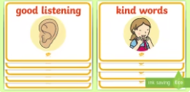  ⃰Available at Twinkl.co.uk | Reinforce expected behaviour in the home setting. Discuss the consequences of inappropriate behaviour/actions. Talk about feelings with your child and help them to understand: happy, sad, angry and scared. Encourage them to express how they might be feeling.  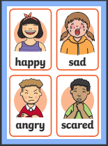
Physical Development | Children will access the outdoor classroom, and develop balance and coordination skills to enable them to travel in a variety of ways, including over, under, through and around obstacle equipment. Pupils will take part in PE in the school hall, playground or field. Children will engage in a variety of fine motor control activities including: threading, construction, mark making and dough activities. Pupils will also access targeted Dough Gym and Funky Fingers activities to support pencil grip and strength. Pupils will practise health and self-care routines including: hand washing, blowing their nose and dressing for PE and the outdoor environment. | Encourage your child to be fully proficient when using the toilet and washing their hands.  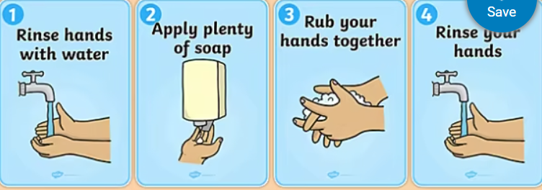  Support children to develop the ability to cope with dressing and undressing.
Communication and Language  Literacy | Children will be encouraged to take part in circle time activities within small groups and whole class. There will be lots of opportunities for pupils to express their views, share stories and become confident to speak in a familiar group. Pupils will have the opportunity to engage in role play to develop their expressive language. Wellcomm Language intervention will be delivered to target pupils to develop their expressive and receptive language and early language development. Children will recall story events and will have the opportunity to re-enact stories in their play. | Encourage your child to speak to a range of adults in the home setting. Encourage your child to ask and answer two part questions and instructions.  Discuss the songs we have been singing at school and the sounds they have been learning in Phonics each week (Reception children only)  Encourage your child to identify letters in the environment, e.g. number plates, signs, magazines etc.  Read a story to your child every day. Encourage your child to talk about the illustrations in the stories. Model how to hold a book correctly and turn pages. Feed your child’s imagination and deepen their vocabulary by telling them a range of stories  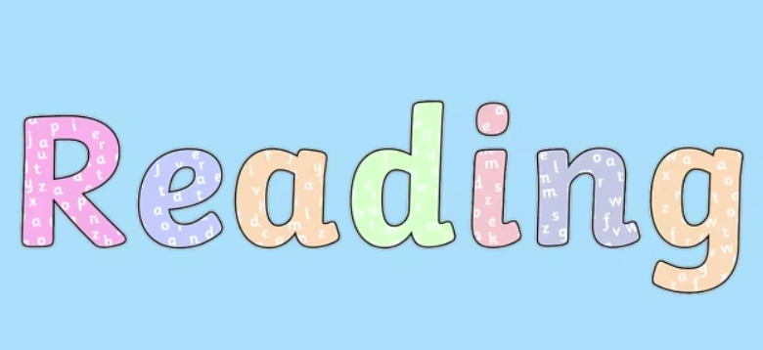
Mathematics | Pupils will be introduced to Numicon, which is a multi-sensory resource to support mathematical concepts, for example pattern, addition and problem solving. Children will consolidate their understanding of the numbers 0-5; counting up to five objects accurately and matching to the correct numeral. Pupils will also develop their understanding of ‘one more’, find the total number of items in two groups by counting and begin to use the vocabulary involved in addition. Children will also explore size and position and 2D shapes. | Practise counting with your child. You might like to count objects in the home setting. Encourage your child to place objects in a line whilst counting and to touch count. Go on a ‘Number Hunt’ with your child. Draw their attention to numbers in the environment for example, on registration plates, buses, doors and encourage them to recognise and name the numerals they see.  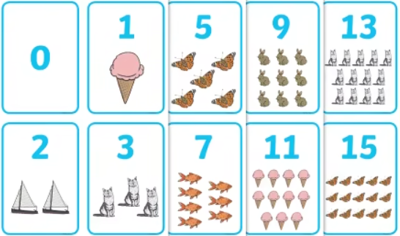  Please follow the links below for further information on Numicon or for educational games to access at home:  • Making Numbers Real-Numicon https://www.youtube.com/watch?v=yYgwM5Z1tMo  • Crickweb-free online educational games for children http://www.crickweb.co.uk/Early-Years.html  • Topmarks-free online Maths games for children https://www.topmarks.co.uk/maths-games/3-5-years/counting
Understanding of the World | Pupils will learn about themselves and their 5 senses. We will have a range of activities to explore taste, touch, sight, hearing and smell. Children will name different parts of the body. We will discuss people and the stages of life (baby, toddler, teenage, adult) and note differences between the stages. We will discuss our families, friends and what we enjoy as we get to know each other. Children will be learning about Harvest, Diwali and the build up to bonfire night. We will be noting the changes in seasons and what they can see is changing around them. Children will learn about Staying Healthy including dental and hand hygiene. | Discuss families and extended family, maybe draw a pictures of these to share with us at school or create a family tree. Encourage your child to observe and describe the signs of Autumn. Collect fallen leaves and allow your child to produce leaf collage pictures. Your child may like to bring fallen Autumnal leaves to school.  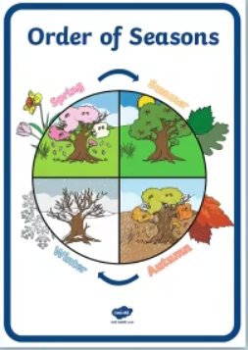
Expressive Arts and Design | Children will explore drawing techniques and will begin to use different types of materials to produce art work (paint, collage, clay, playdough and pastels) During child initiated learning pupils will have access to a wide variety of creative materials and will be able to express their own creativity. Pupils will be able to access a variety of small world and role play activities to develop expressive language. Pupils will develop their repertoire of Nursery Rhymes, Action Songs and themed songs. They will use Music Express to develop an understanding of rhythm and beat within music | Encourage your child to sing songs from school in the home setting. Allow your child to access a wide range of creative activities: painting, collage, creative role play etc. Why not make a Leaf Man with your child?  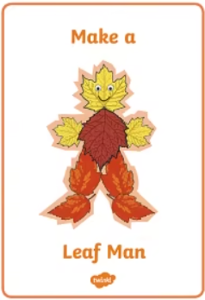
Religious Education | Our R.E topic this half term is God’s World.  Children will learn about the things God created and ways to take care of these.  Children will learn that we are all unique and that we all share similarities and differences. Children will learn that God loves every one of us.  Children will learn how to make the Sign of the Cross and join in with our daily class prayers. | Encourage children to point out the things God made in the world (plants, animals, the sun, moon etc.)  Maybe your child would like to bring in a photo of your pet if you have one and talk to us about how they take care of their pet.  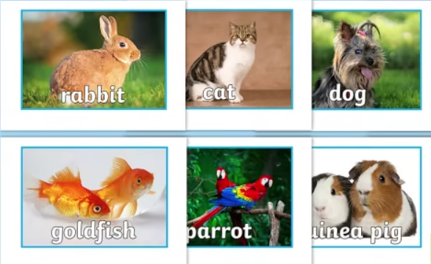
Please send in a pair of welly boots and a cycle helmet (both clearly named) for your child to keep in school. You may also like to provide a change of clothes in a named bag in case of toileting accidents or muddy weather. Please ensure all water bottles and lunchboxes are clearly named. Water is available throughout the day and your child will be offered a healthy snack each morning and afternoon.
Reception children will also need to come into school wearing their PE kit every Friday starting from Friday 9th September. Please ensure all items of clothing are clearly labelled. Nursery will begin their P.E sessions following the October half term break and will therefore also need to come dressed in P.E kit to school from Friday 4th November.
All children will need a set of waterproof trousers and jacket for Forest School sessions on Thursday afternoons. Please ensure these are clearly labelled and kept in a carrier bag as they should get muddy! Forest school sessions will begin on Thursday 15th September.
Home-School diaries will be checked every morning for messages by a member of staff. Please use these to communicate any messages you’d like us to read and to comment on your child’s reading at home. We will also use the diaries to let you know if your child has any minor incidents throughout the day.
If you have any questions please feel free to catch us at drop off or collection times and we will be happy to make an appointment to discuss all queries or concerns.
We look forward to a busy and exciting term ahead!
The Early Years Team



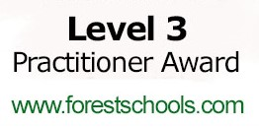


“Learn, love and respect through Jesus”

