St Thomas of Canterbury Catholic Primary School
Headteacher: Mrs M Keating
“Learn, Love and Respect Through Jesus” St Francis of Assisi

CATHOLIC ACADEMY TRUST
21 April 2023
Dear Parents and Carers,
A warm welcome back to school to all families, we hope you had a restful and happy Easter. This term we welcome Mrs Reid (Teaching Assistant) to our Early Years team to cover Mrs Scher’s Maternity leave. Please see the information below for this half term’s staffing and curriculum in the Early Years.
 | Monday | Tuesday | Wednesday | Thursday | Friday
Staffing | Mrs Overett (Class Teacher)  Mrs Reid (Teaching Assistant)  Mrs Healy (Teaching Assistant) | Mrs Clark (Class Teacher)  Mrs Reid (Teaching Assistant)  Mrs Healy (Teaching Assistant - PM) | Mrs Clark (Class Teacher)  Mrs Smith (Teaching Assistant)  Mrs Healy (Teaching Assistant) | Mrs Overett (Class Teacher)  Mrs Smith (Teaching Assistant)  Mrs Healy (Teaching Assistant) | Mrs Overett (Class Teacher)  Mrs Reid (Teaching Assistant - AM)  Mrs Smith (Teaching Assistant)
⃰Parent volunteers are always welcome in the Early Years class. This term in particular we are looking for volunteers to talk to the children about their profession. Please contact a member of the team if you think you can help!

This term our Class Act Of Worship is on Tuesday 13th June celebrating Father’s Day, which you are invited to come and watch. We hope that you can join us!
Curriculum Information - Topics
Autumn 1 2022 | Autumn 2 2022 | Spring 1 2023 | Spring 2 2023 | Summer 1 2023 | Summer 2 2023
My 5 Senses | Shadows and Light | Fantasy and Adventure | Jurassic Journey | Materials | People who help us
Below we have highlighted some of the key learning intentions for the beginning of the Summer Term, however please note these are not exhaustive and will be adjusted and adapted to suit the needs of individual children and the entire cohort.
Summer 1 Curriculum
Curriculum Area | Nursery & Reception | Home Enrichment Activities
Personal, Social and Emotional Development | To understand some ways in which we can look after our world and why this is important.  To develop their sense of unique self by talking about similarities and differences to others.  To think about the perspectives of others.  To explain how they can demonstrate friendly behaviour.  To manage their own needs. | Reinforce expected behaviour in the home setting. Discuss the consequences of inappropriate behaviour/actions. Play turn taking games and reinforce that winning and losing are both OK. Talk about feelings with your child and help them to understand: happy, sad, angry and scared. Encourage them to express how they might be feeling.  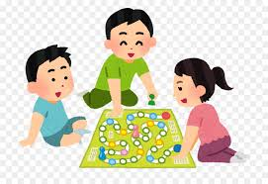
Physical Development | The children will learn to assess risks involved in using hammers and nails and they will develop safety awareness, balance and coordination skills to enable them to travel in a variety of ways, including over, under, through and around obstacle equipment. Children will continue to engage in a variety of fine motor control activities including: scissor control, threading, construction, mark making and dough activities. We will support all children to develop their pencil grip and pencil control further. | Encourage your child to dress and undress independently wherever possible including having a go at zips on coats and Velcro shoe straps or buckles.  Support your child in assessing and taking appropriate risks such as using a new piece of playground apparatus at the park.  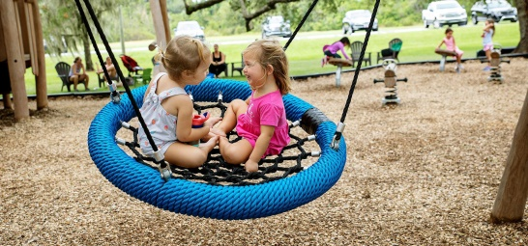  Encourage proficient and independent hand washing before snacks, meals or any food prep.
Communication and Language  Literacy | Children will continue to be encouraged to take part in circle time activities within small and large groups. There will continue to be lots of opportunities for pupils to express their views, share stories and become confident to speak in a familiar group and we will continue to support children in responding to ideas expressed by others with relevant comments and questions. Children will be encouraged to use talk to help work out problems and organise thoughts  Children will be introduced to a wide range of vocabulary linked to our Materials topic, including man-made, raw, natural, magnetic, metal, plastic, recycling.  Wellcomm Language intervention will continue to be delivered to target pupils to develop their expressive and receptive language and early language development. | Encourage your child to have a go at labelling any pictures they draw or models they create. Other opportunities for writing at home include writing shopping lists, writing cards to family or friends, making tickets for shows or movie nights. It is fine for Nursery’s writing attempts to just be marks on paper!  Reception children will continue to bring home phonics sheets to help consolidate our phonics learning each week.  Read a story to your child every day. Encourage your child to talk about the illustrations in the stories. Model how to hold a book correctly and turn pages. Feed your child’s imagination and deepen their vocabulary by telling them a range of stories
Mathematics | Children in Nursery will be learning to count and recognise numbers from 5-10 and beyond if they are ready. They will also be using the language of space, size, distance and time sequence.  Children in Reception will become competent in subitising and counting on or back within 10, finding 1 more and 1 less, learn and know by heart their number bonds to 5 and then 10. We will then develop understanding of tens and ones of teen numbers to 20. Children will use tens frames and number lines competently to solve mathematical problems including addition and subtraction. | Practise counting, sharing amounts between two groups and recognising numbers with your child.  You might like to go on a ‘Shape Hunt’ searching for and describing basic 2d (square, rectangle, triangle, circle) and 3d (sphere, pyramid, cone, cube, cuboid) shapes around your home.  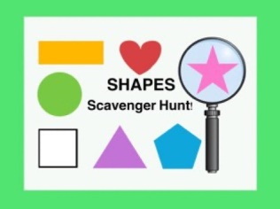
Understanding of the World | Children will be learning about the properties of different materials and the difference between raw and man-made materials.  We will also be learning about the changes to the season and searching for these changes in the environment.  For our ‘People who help us’ topic we will learn about the roles of different professions and Road Safety. | Go on walks and point out the changes that are taking place in the environment as we move towards summer.  Discuss recycling materials and how you do this in your home. Point out different materials and their properties in the environment.  If any parents would like to talk to the children about your profession, we’d love to hear from you! Please contact a member of the Early Years Team.
Expressive Arts and Design | Children will be taught a range of skills to help them develop confidence and enjoyment of expressive arts, from singing and dancing to selecting appropriate media and materials to create. | Allow children to explore creatively using tools such as paintbrushes, dabbers, sponges. Encourage creative role play and expression through music / singing.  Perhaps you can research an artist and share what you find on Tapestry? We’d love to hear from you!
Religious Education | Our R.E topic this half term is New Life  Children will learn about the joy Jesus brought at Easter and about his Ascension to his Father in heaven. We will also learn about Mary, the Mother of Jesus and why she is so special. We will look for signs of new life in the beautiful world around us and thank God for these things. | Go for a Summer walk to look for signs of new life such as flowers and baby animals growing.  Say prayers to thank God for the beautiful world He has created.
Home-School diaries will be checked every morning for messages by a member of staff. Please use these to communicate any messages you’d like us to read and to comment on your child’s reading at home. We will also use the diaries, as well as Tapestry, to let you know if your child has any minor incidents throughout the day.
Please note to support Reception with their transition to Year 1, the children are now asked to separate with parents at the black millennium gates and go around onto the playground with the rest of the school at the start of each day. They will also join the rest of the school for playtimes on the playground. In the latter half of the summer term, Reception will begin visiting their new class every Tuesday afternoon to familiarise themselves with the adults and classroom environment.
If you have any questions please feel free to catch us at drop off or collection times and we will be happy to make an appointment to discuss all queries or concerns.
We look forward to another busy and exciting term ahead!
Mrs Overett Mrs Clark
EYFS Teacher EYFS Teacher

