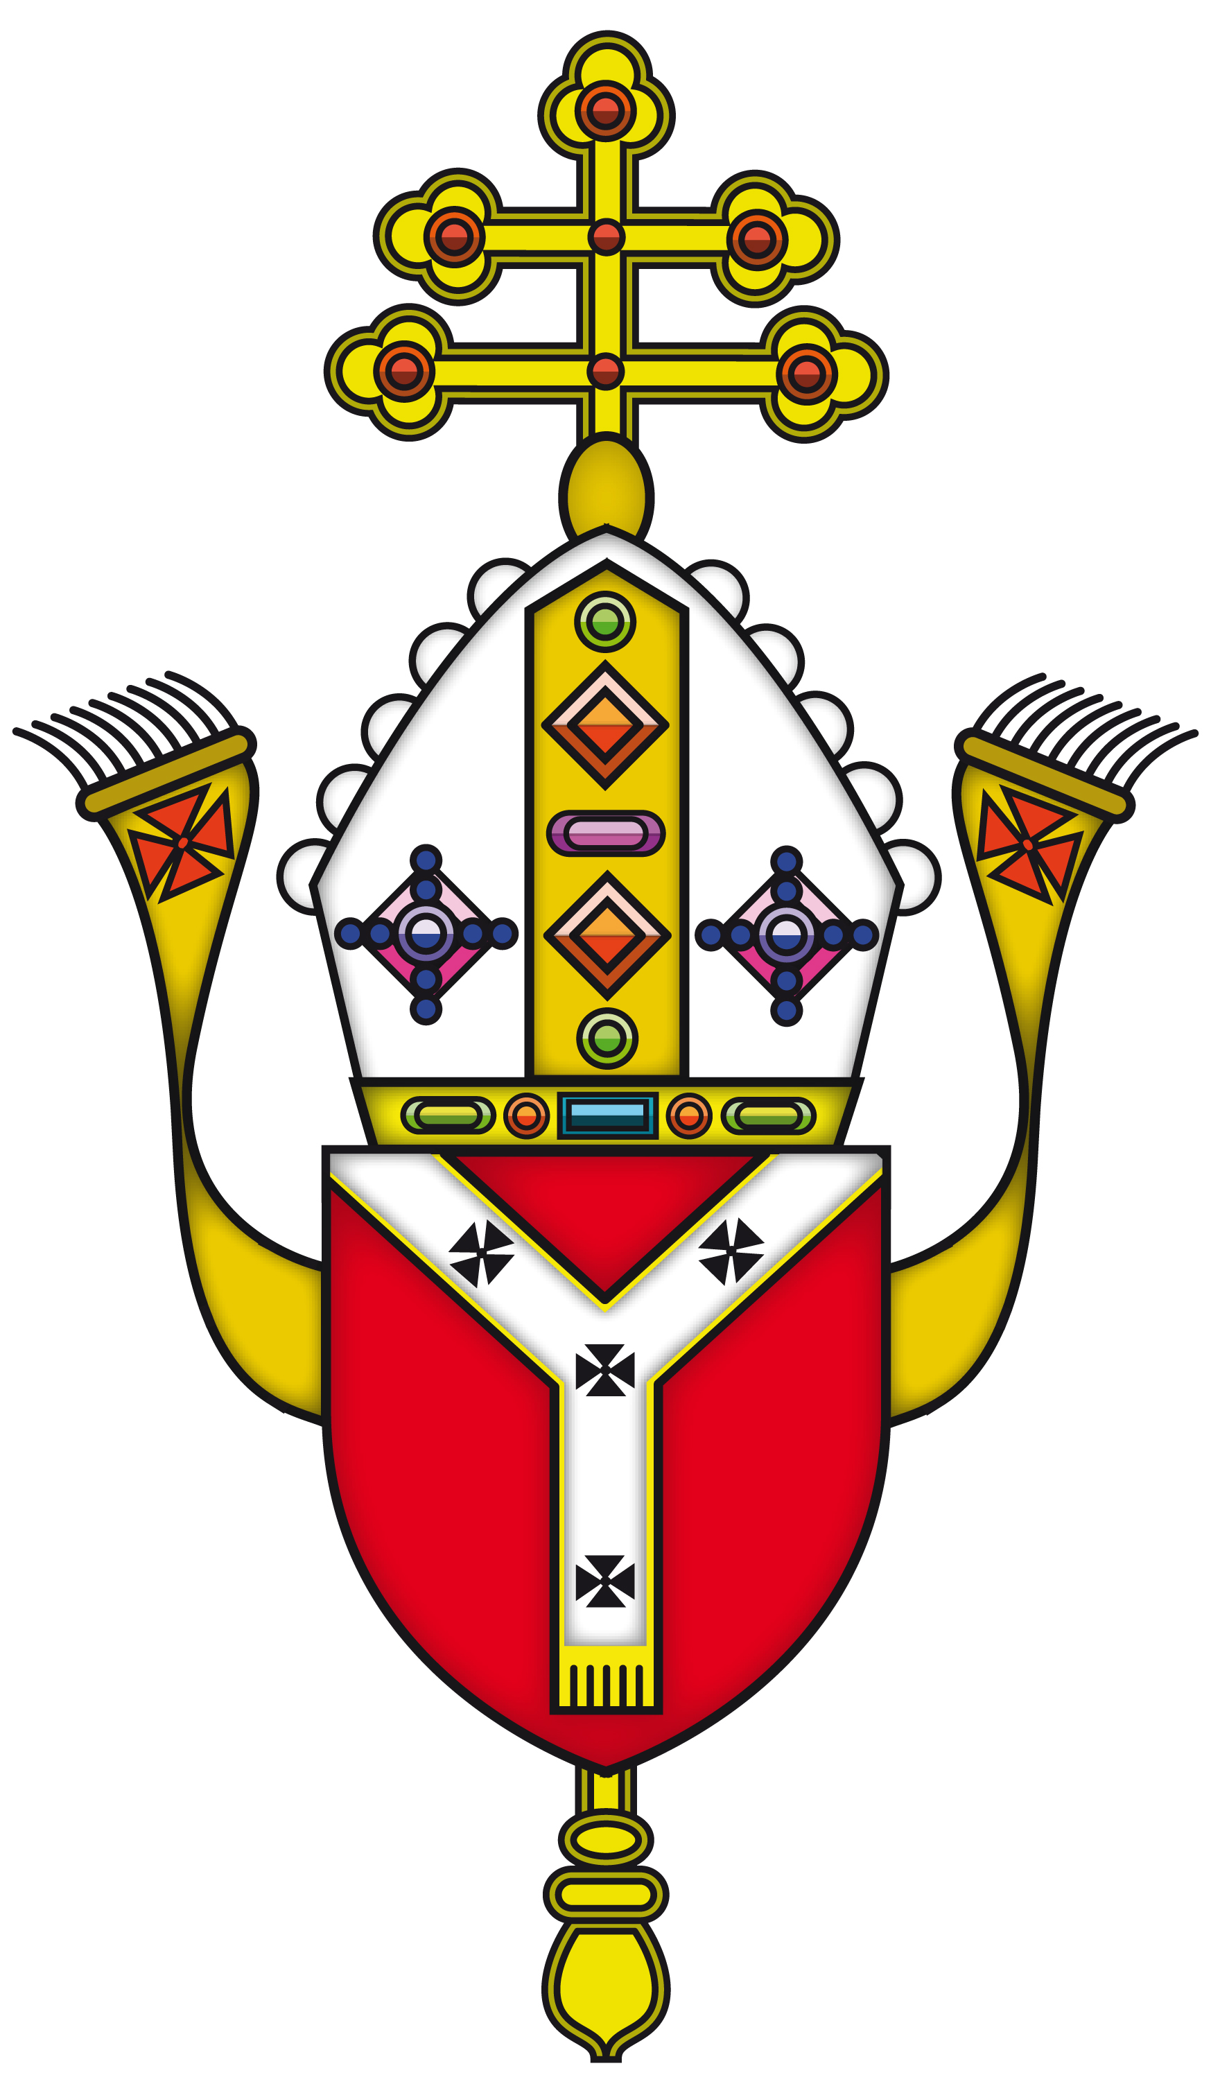
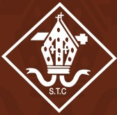
ST THOMAS OF CANTERBURY CATHOLIC PRIMARY SCHOOL

High Street, Puckeridge, Herts SG11 1RZ

Tel: 01920 821450

Headteacher: Mrs Michelle Keating BEd (Hons) Website: www.stcanterbury.herts.sch.uk
Assistant Head: Mr Andrew Booth BSc (Hons) E-Mail: admin@stcanterbury.herts.sch.uk

Friday 16th April 2021

Dear Parents,

Welcome back for the Summer Term, I hope you all enjoyed the sunshine (and snow!) over the Easter break.

It was lovely to have the few weeks before the holidays to settle the children back into school life.

This term will certainly be busy, we are beginning to use informal assessments to work out where the children are and what their shorter term and longer-term targets should be. These will be shared with you during our upcoming parent consultations and, later in the term, school reports. In Maths particularly we are working on areas that were not covered during lockdown and recapping areas that were to ensure children are ready to progress to the content for the next academic year. I have noted that many of the children still need to secure their recall and application of multiplication facts so I will be setting this as a recurring weekly homework.

English will also be focused on continuing to build basic skills and develop stamina lost during the home learning period. We will be ensuring that handwriting, reading and spelling skills are practiced and reinforced regularly, with additional support for those children who require it.
We are working hard to provide the children with opportunities to catch up on lost learning, these may include sessions before and after school as well as planned intervention within the school day. We are very grateful to have Mrs King back in school a day a week and she will be working with groups of children to help with areas for development.

In RE this term, our focus will be ‘Celebrating Easter and Pentecost’ and ‘Belonging to the church’. The first topic will be looking at the events occurring around Easter, how we celebrate these and what is meant by Pentecost. ‘Belonging to the church’ looks at the wider Catholic community and our part in it.

Our History this term is all about the Romans. We will learn about the Roman invasion of Britain and the impact it had. We will find out about the resistance by Boudicca as well as looking at Roman artefacts including mosaics-which will form the basis of our art topic. We will also be exploring the construction of Roman roads.

In Geography the children will be looking at cities in the Americas. This will include what makes a city, how they develop and comparing city life to different parts of the continents. This is a great opportunity for the children to broaden their geographical knowledge and look at life in different parts of the world.

We have a busy term of Science, finishing off a growing plants topic (including some planting in the school allotment area) and looking ahead to two new topics which are ‘Living things’ and ‘The Big Build’. Our Living things topic will teach the children to recognise that living things can be grouped in a variety of ways. They will explore and use keys to identify and name a variety of living things. Looking at habitats will also be an important part of this unit and will give us many opportunities to learn outside the classroom. ‘The Big Build’ will involve learning about building towers and bridges, starting with constructing tall towers, then exploring bridges, next they look at animals as builders and finally engage in researching famous engineers and architects and the structures they built. We also have a very exciting Science week planned for the week of 17th May!

PSHE will continue to be a key focus across the school, particularly ensuring the children feel safe and happy back in school following the lockdown. We will be working on topics about relationships and changes as well as additional work on resilience and mindfulness.

We will also be having weekly French lessons to consolidate basic phrases and conversational skills.

Mr Hill will lead Computing and Music sessions and PE will continue to be taught by Mr Fitzgerald. This term’s coaching will include tennis, cricket and athletics. We will be continuing to build fitness through our regular mile runs which not only help physical fitness but help with concentration and positive learning behaviours. Please ensure your child has full PE kit in school every day. This should be clearly labelled, particularly as I know many of you will be purchasing new items when the shops reopen this week.

Homework

Homework will continue to be set weekly via Teams and the children will also have a project to complete later in the term. Spelling tests will continue to be every Thursday. Please ensure that the children are using EdShed for spelling and tables practice. Some other tasks will also be set via this platform.

As always, should you have any questions or concerns please do not hesitate to contact me. The easiest way to do this to catch me at the gate, phone the school or via an email to MrsWClark@stcanterbury.herts.sch.uk

Kind regards,

W.A.Clark

Mrs W Clark
Senior Teacher


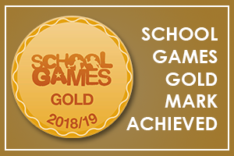


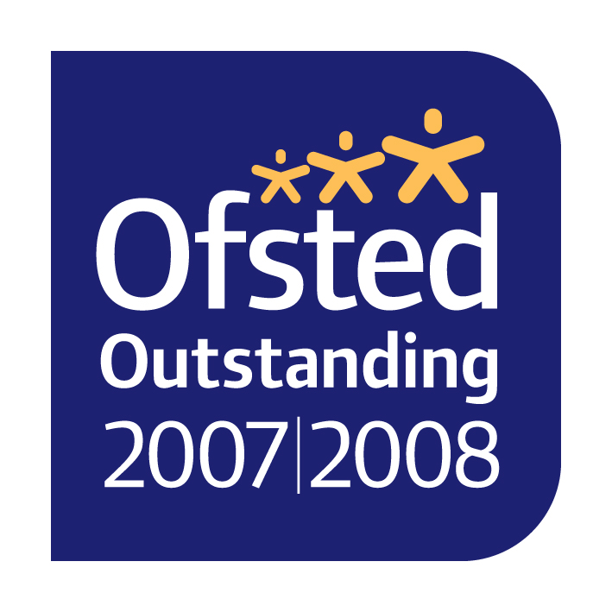

“Learn, love and respect through Jesus”

